Terraform - 03

- Watch the Terraform-03 video.
Completed

- Execute the script shown in the video.
Lets check the variables in Interactive Mode

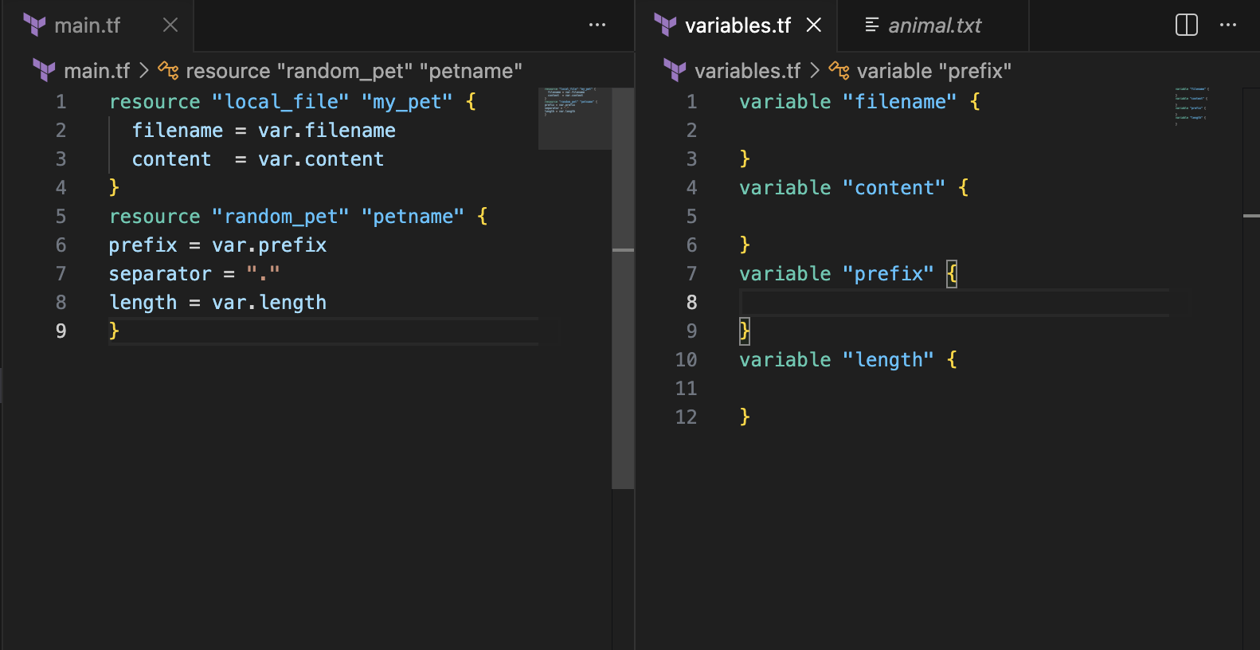
Now lets use CLi and try
terraform apply ⇒ once u use this command it will be asking you to enter the variable. This type of variable can be used for securing the secrets without hardcoding it.
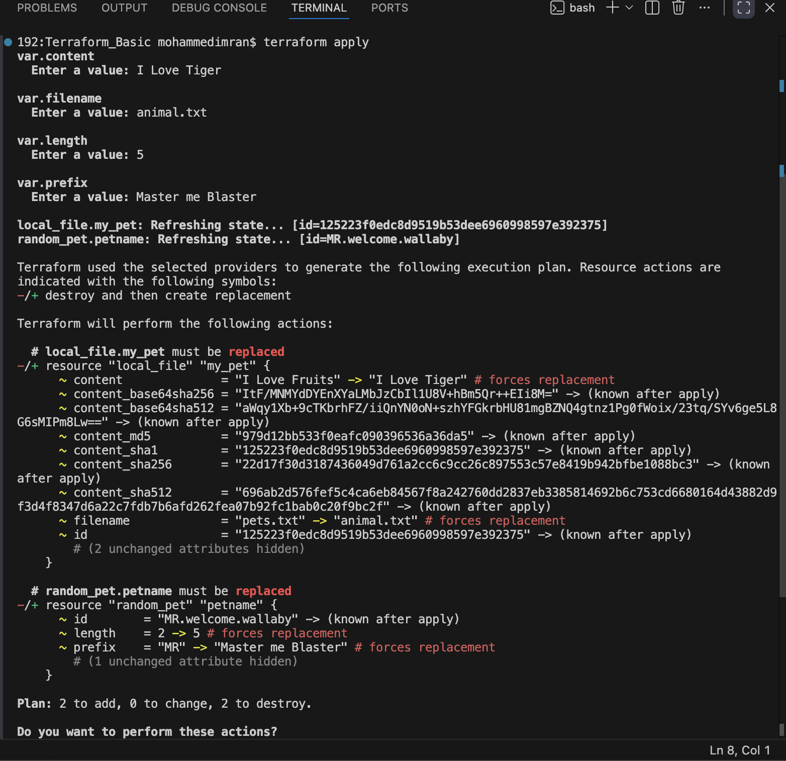
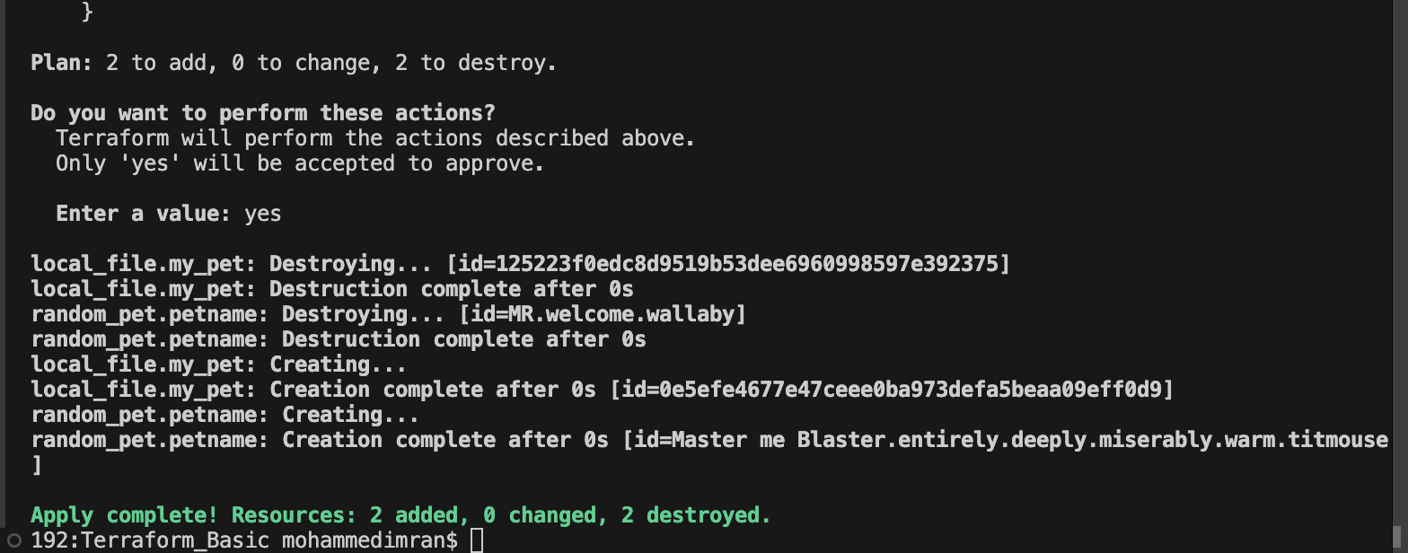
Now lets check if it has worked or not
Previously it was different and now it changes to what variables we defines in the cli
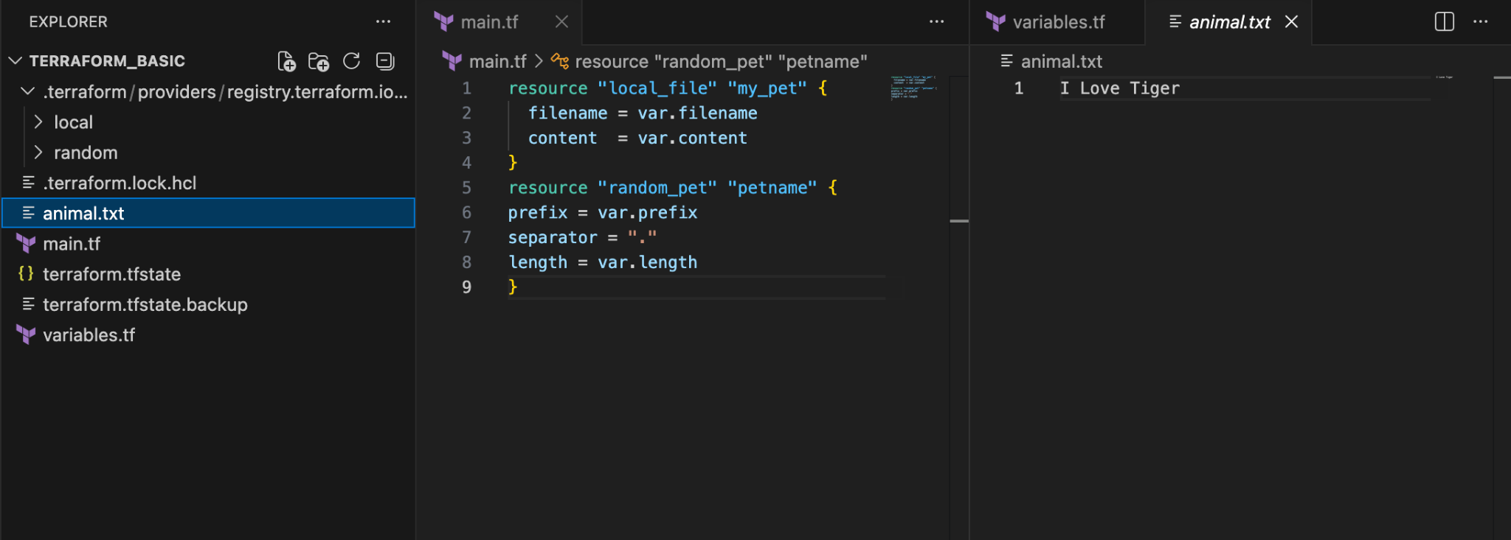
COMMAND LINE FLAGS
Instead of passing variables in variable.tf or interactive mode we can use CLF where we will be giving the values directly like below
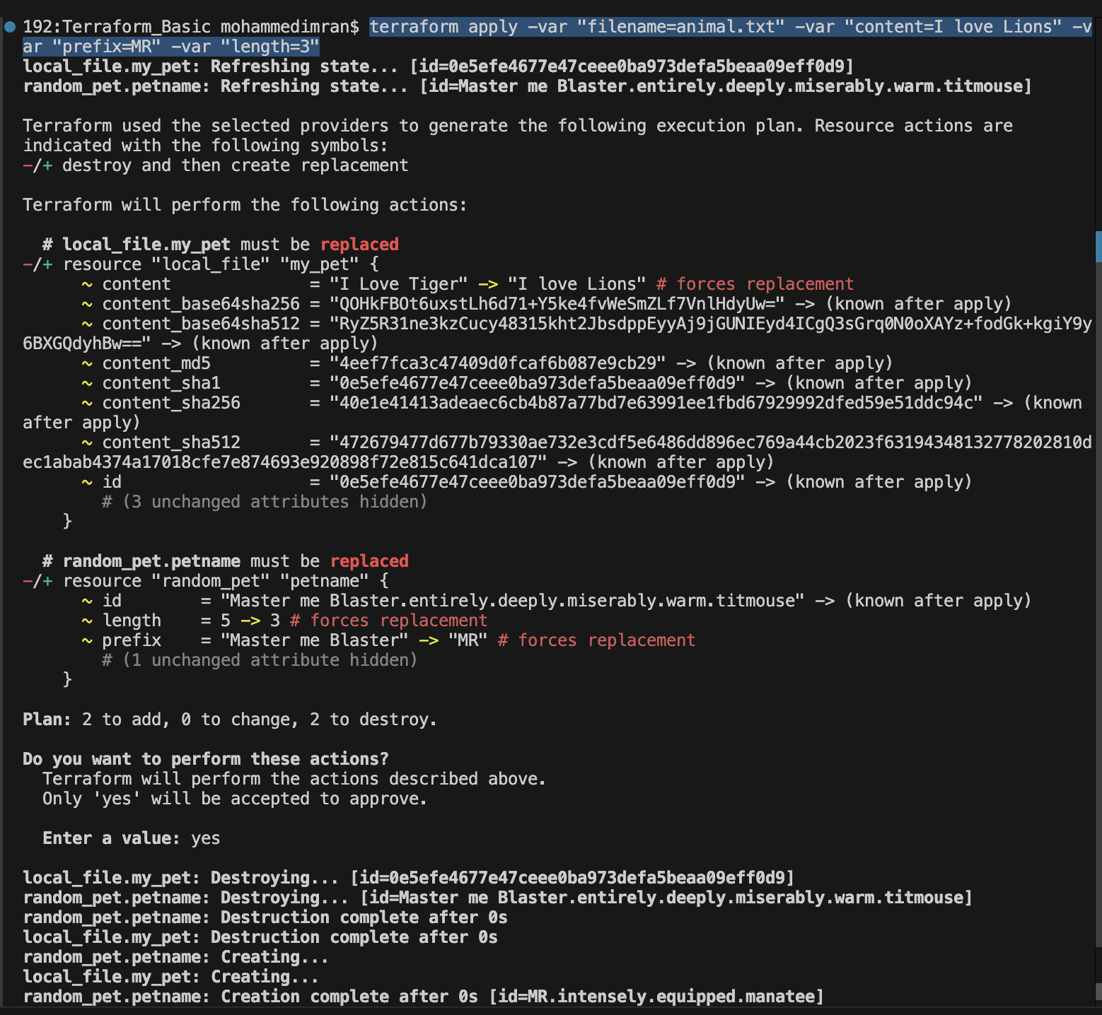
Changed
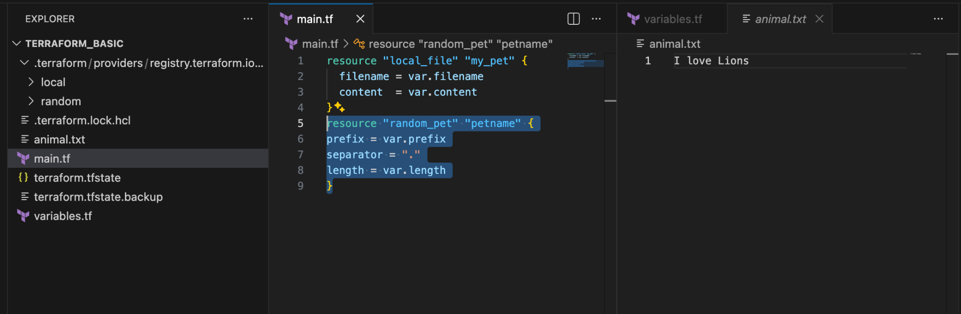

ENVIRONMENT VARIABLES
Used of Password/credential if we don't want to store in variables.tf
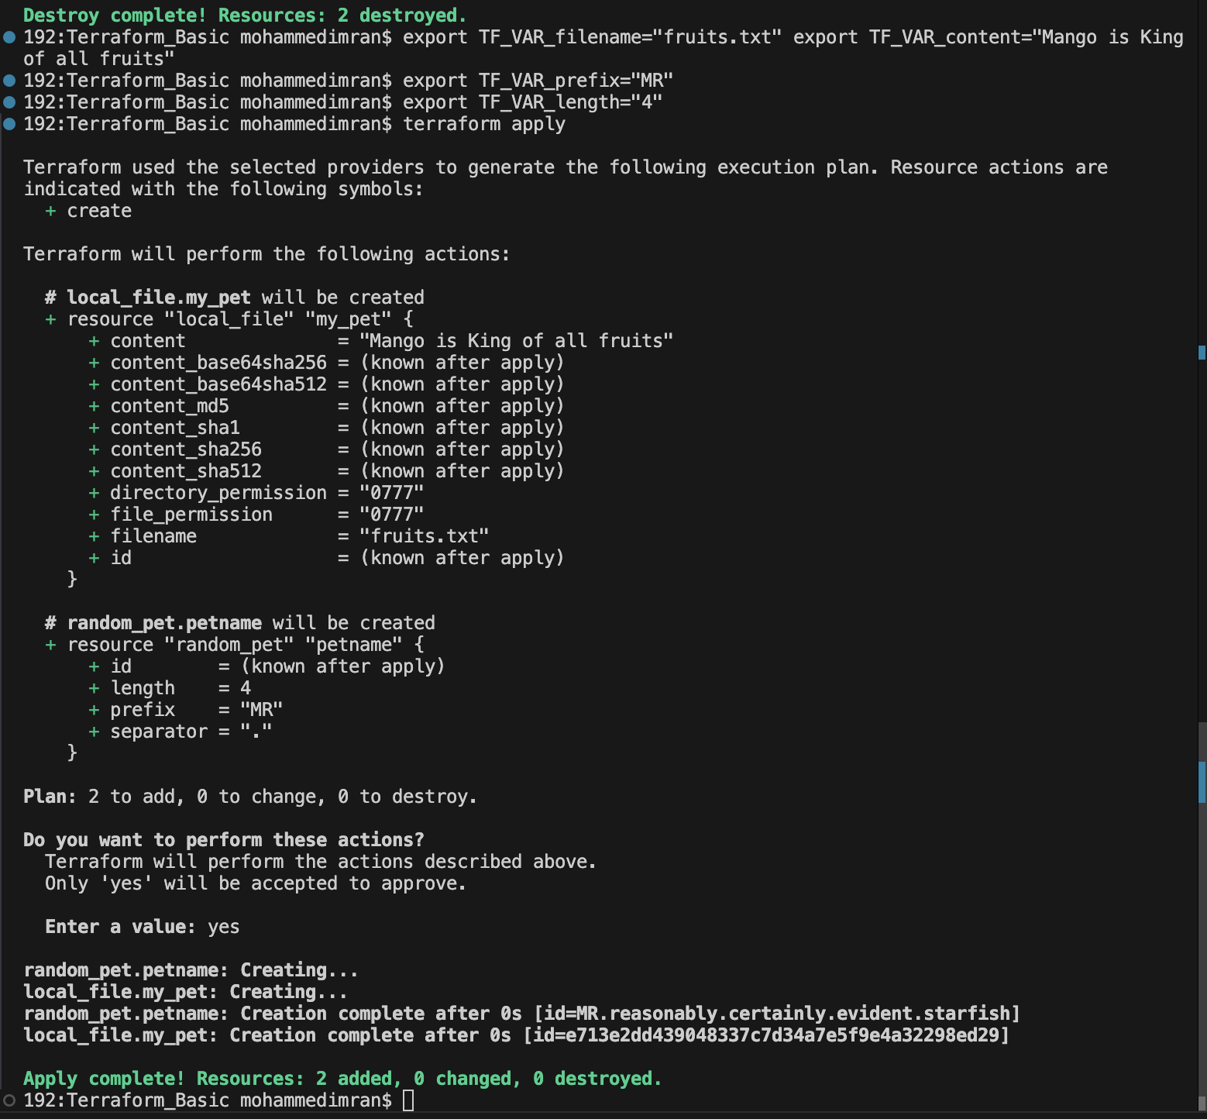
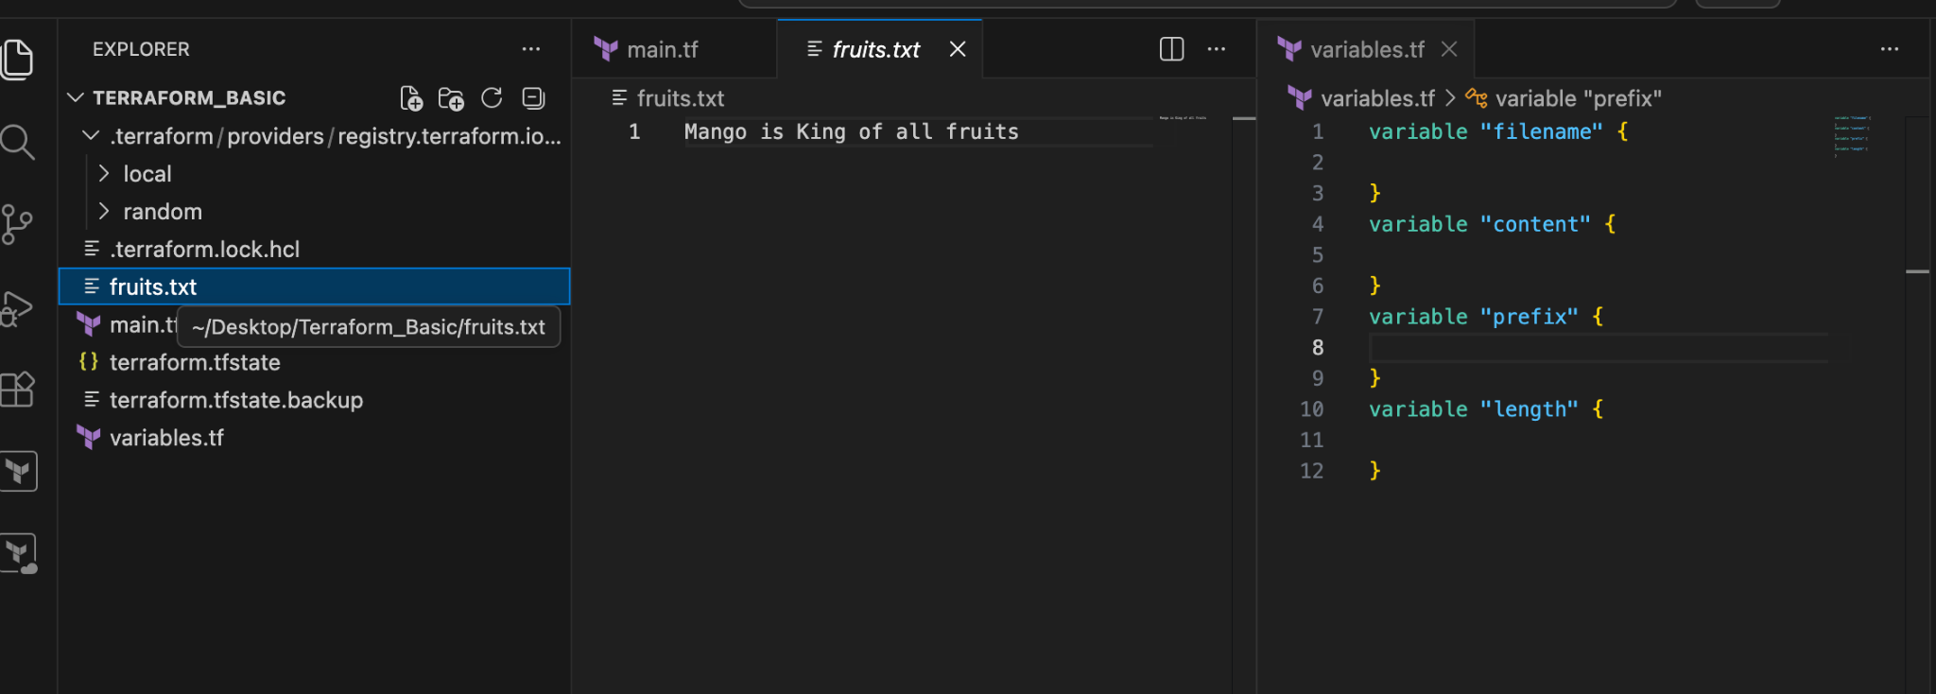
VARIABLE DEFINATION FILE:
In this we will be having terraform.tfvars file where will be giving our variable data but we also need to have variables.tf file
So i created a file with terraform.tfvars
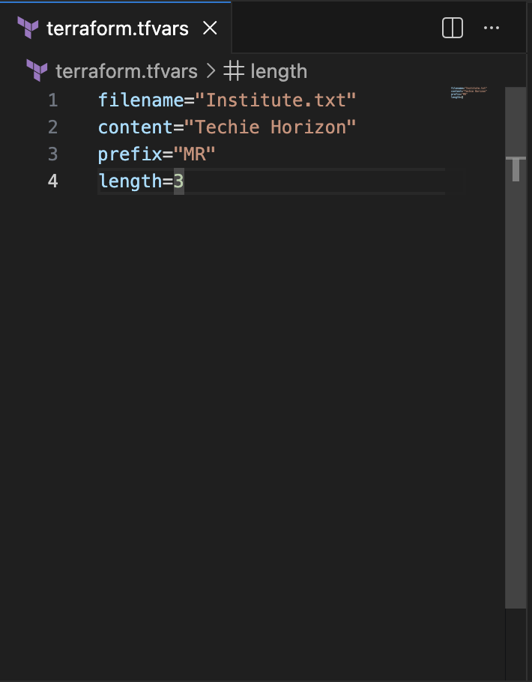
I also have my variables.tf
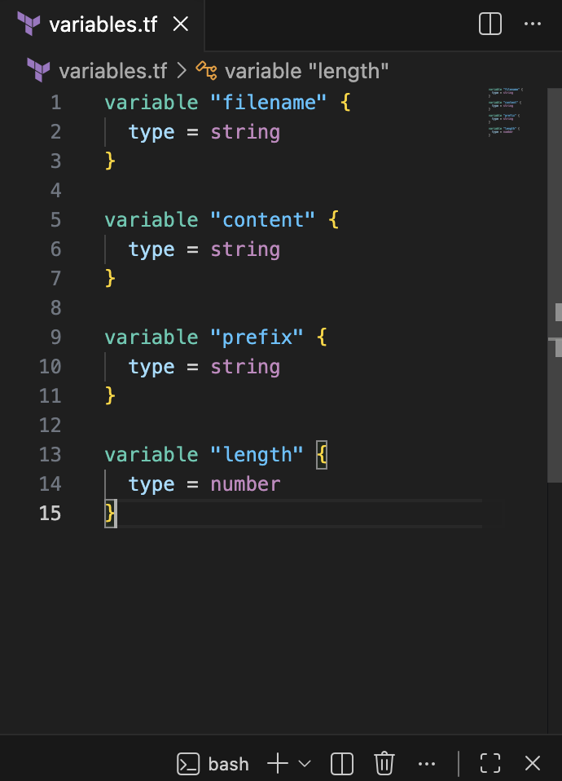
main.tf
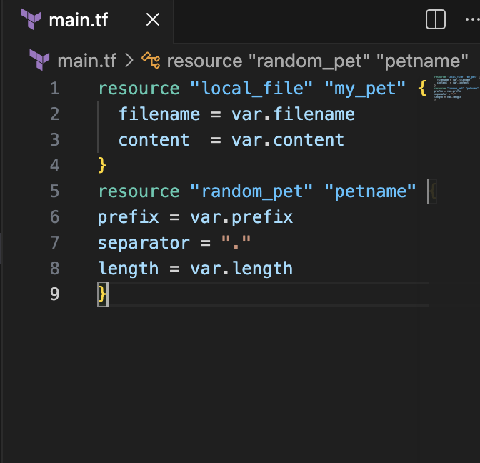
Lets do terraform apply
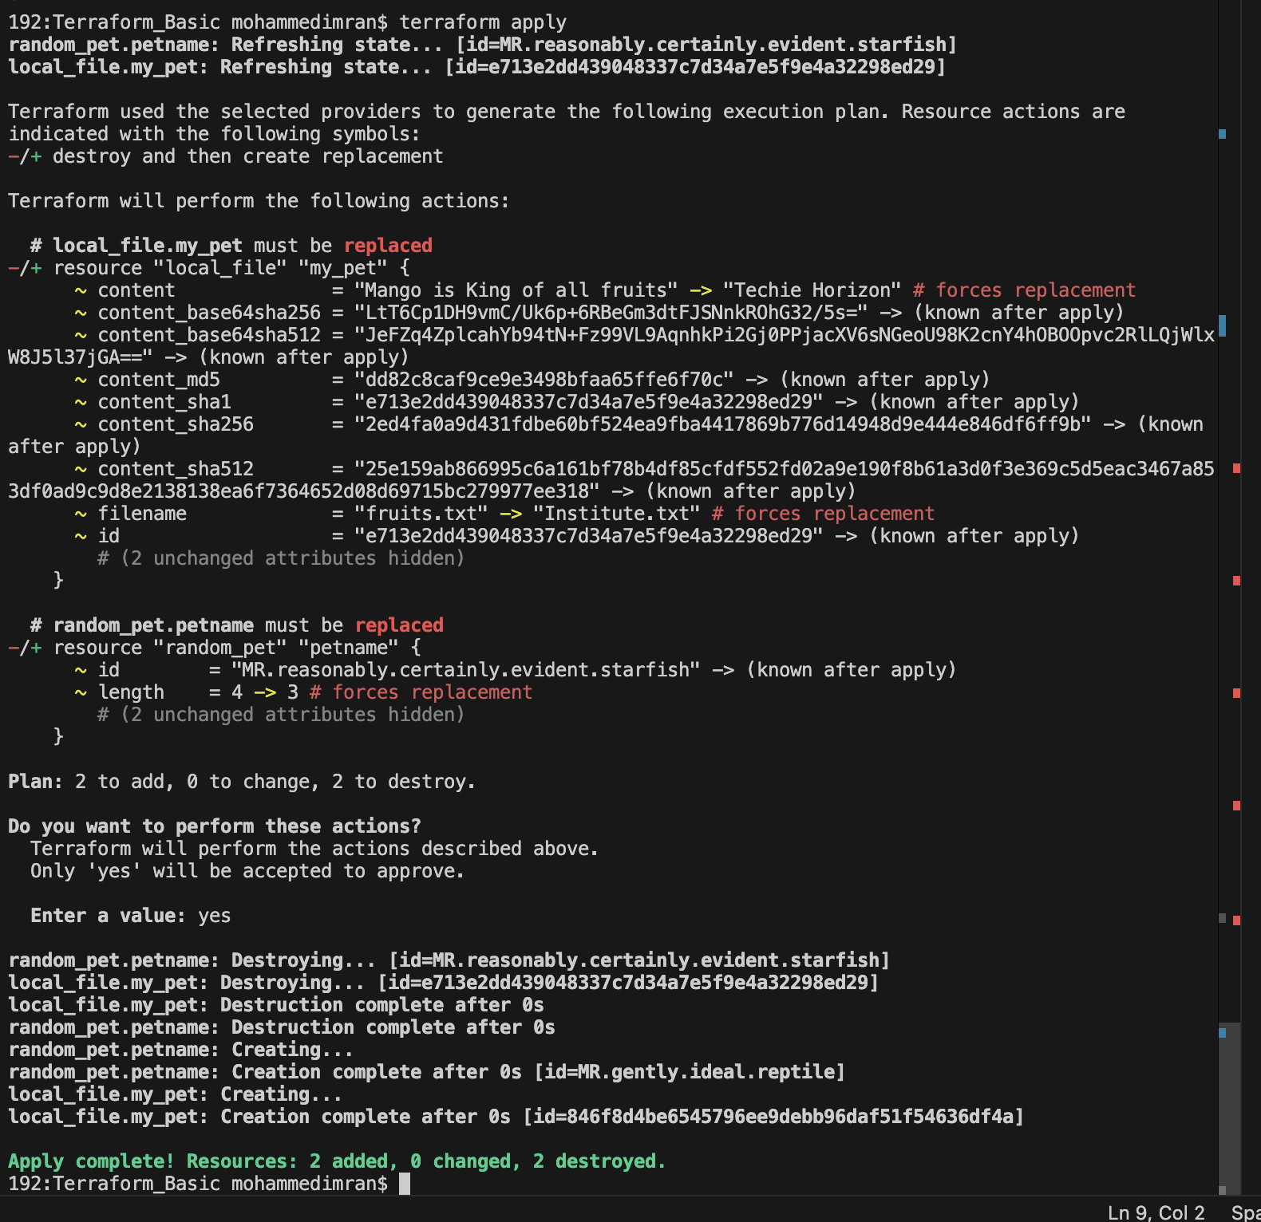
Lets check the output
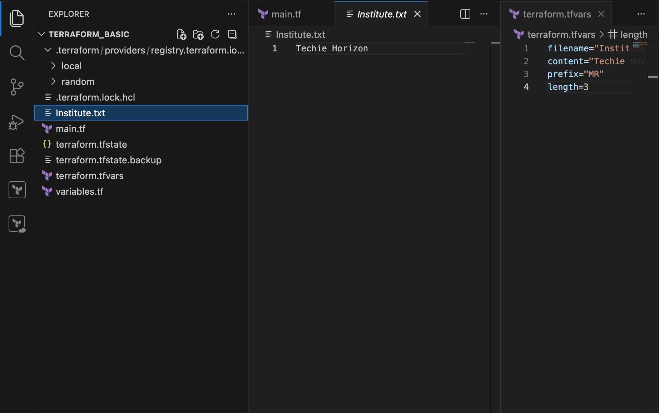

RESOURCE ATTRIBUTES

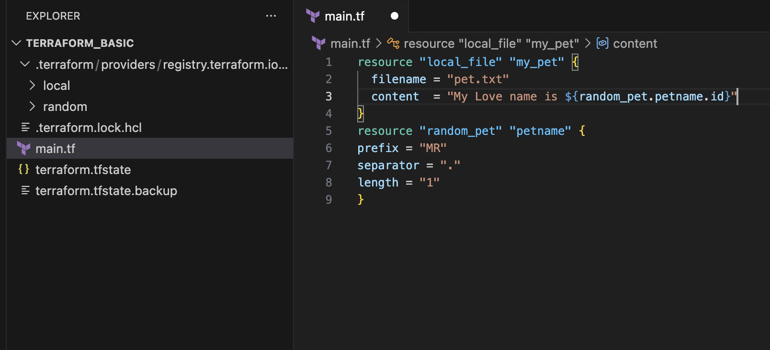
Lets execute terraform apply
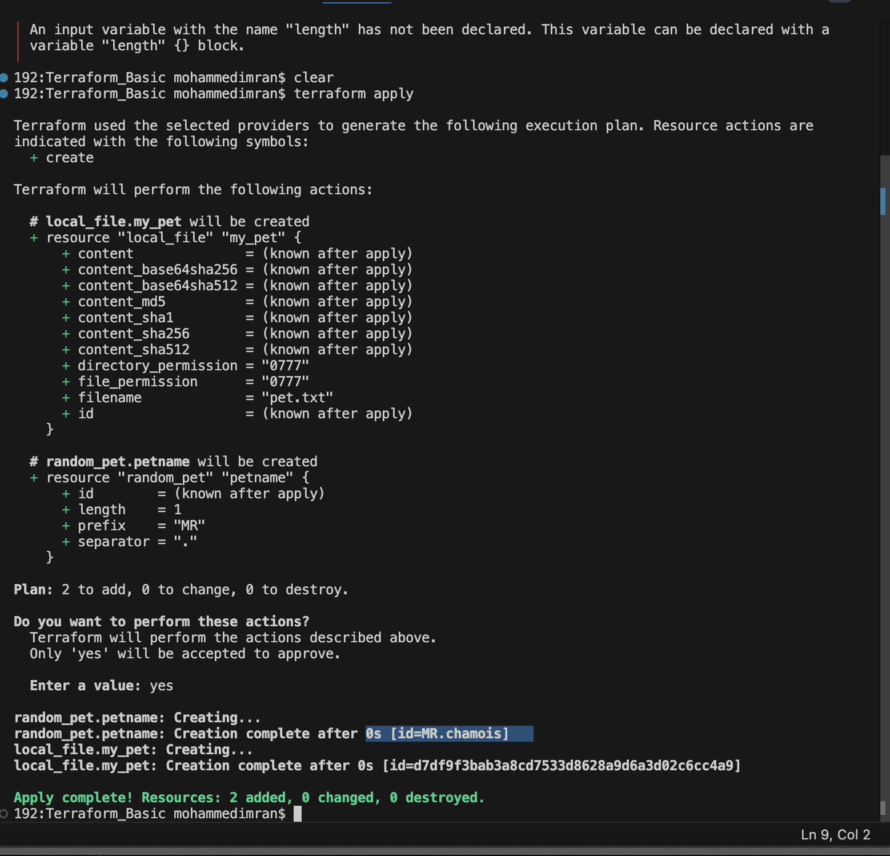
Lets check the output file
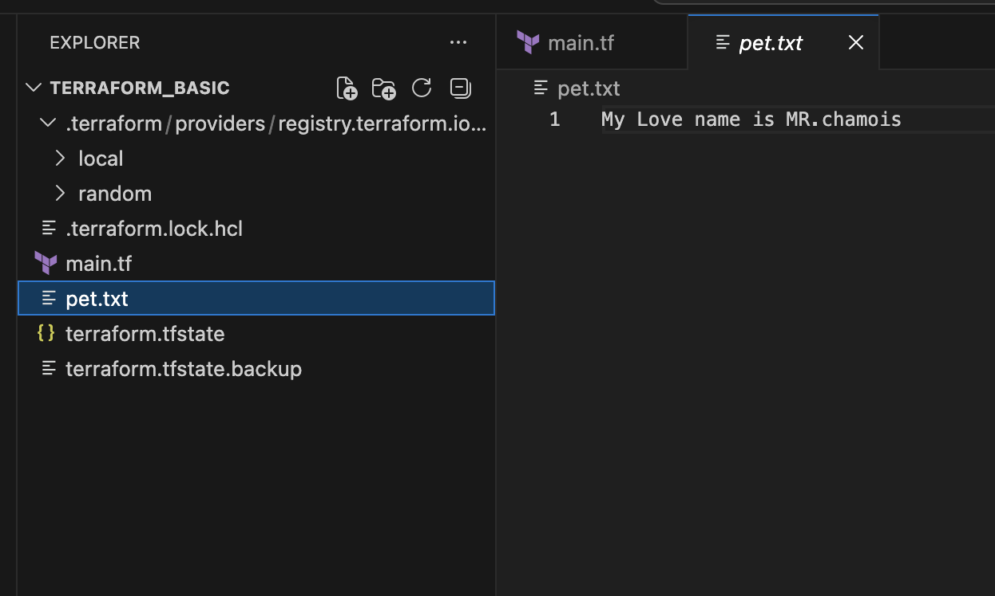
For Outputs to display
By execute terraform output⇒ itrs not displaying anything as we haven't mentioned anything in our main.tf file
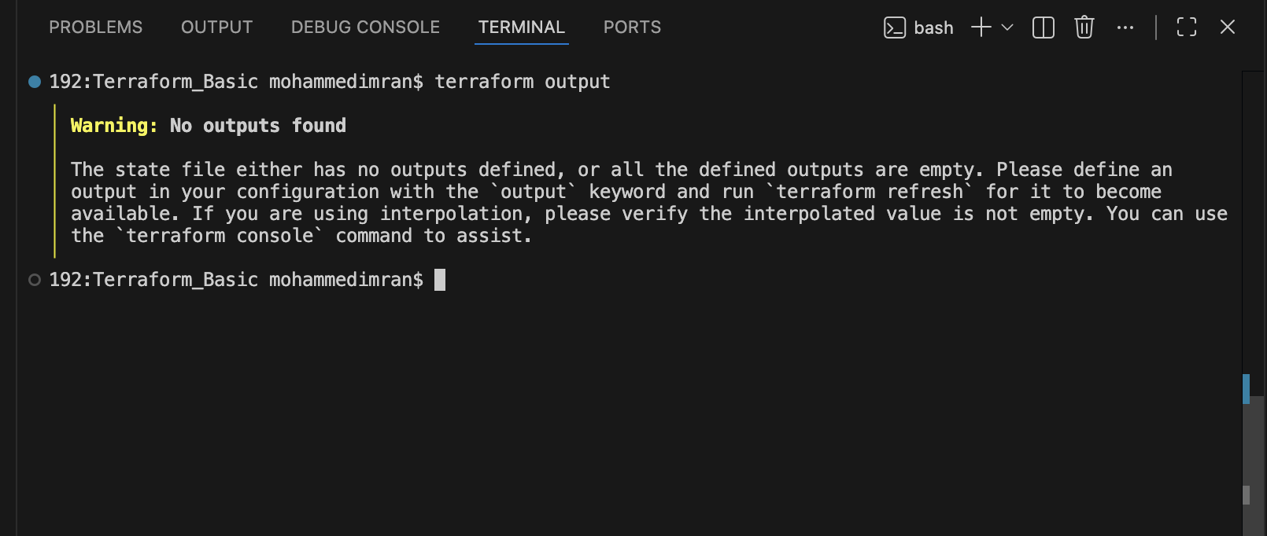
We will make changes in main.tf file
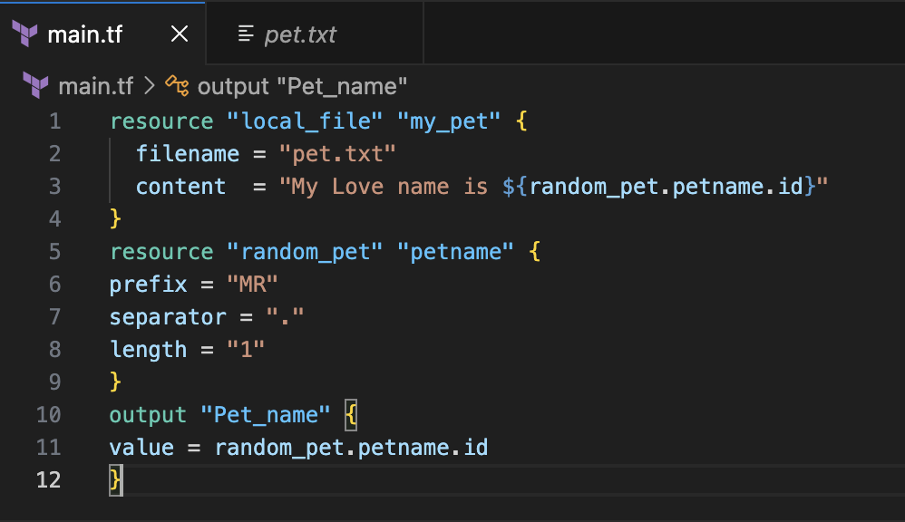
Lets execute command
terraform apply
Now we can see the output also
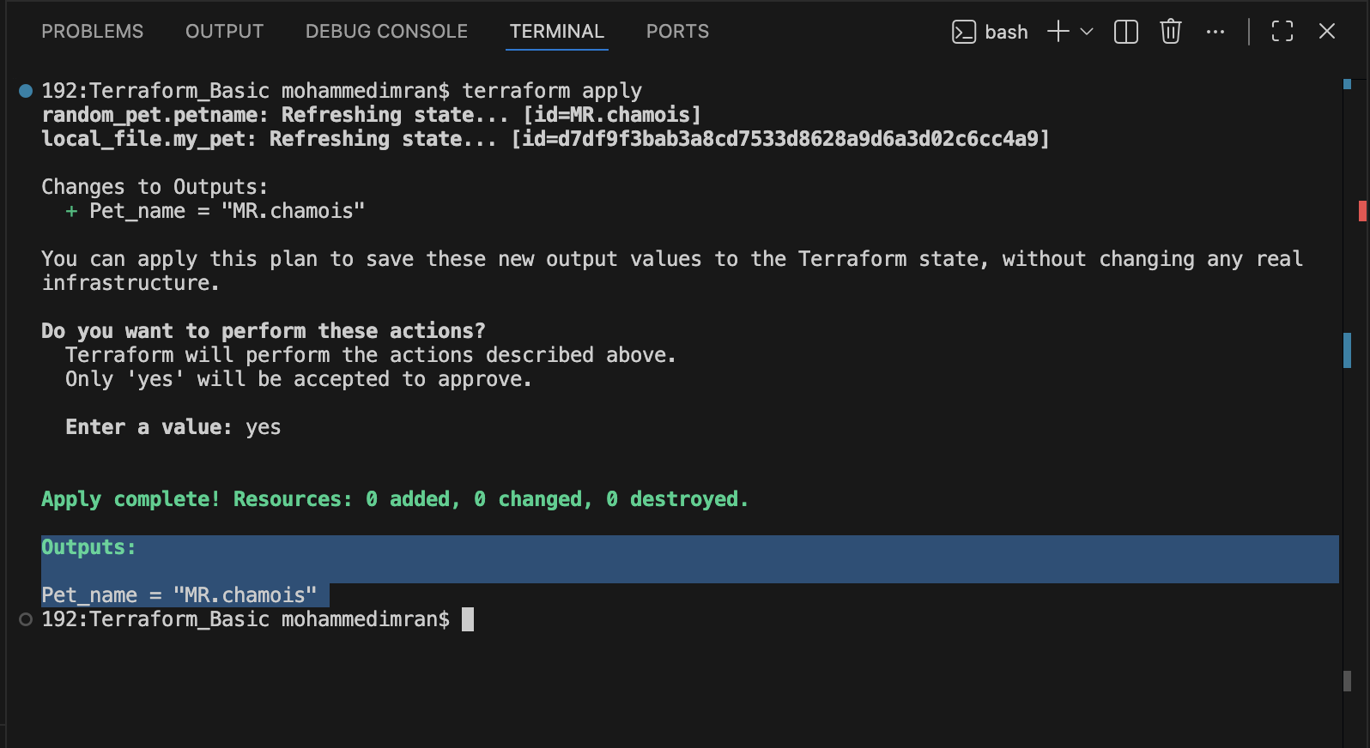
We can use terraform output
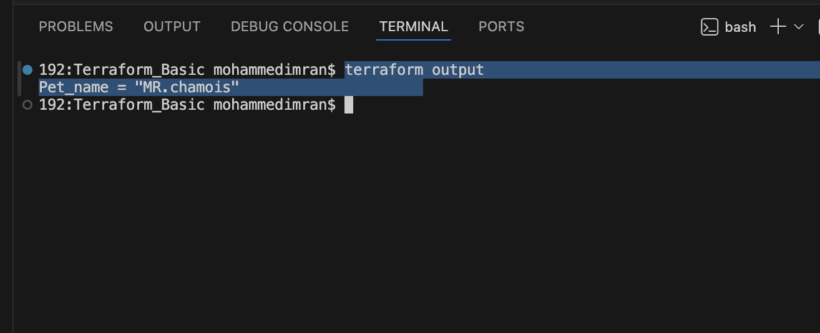

terraform show ⇒ is used to display the current state of Infrastructure
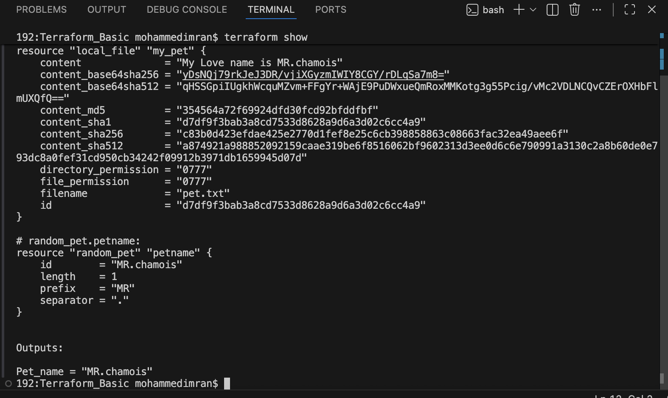

- Integrate Terraform in Jenkins using the Terraform plugin.
Lets start Jenkins and Install the required Plugins
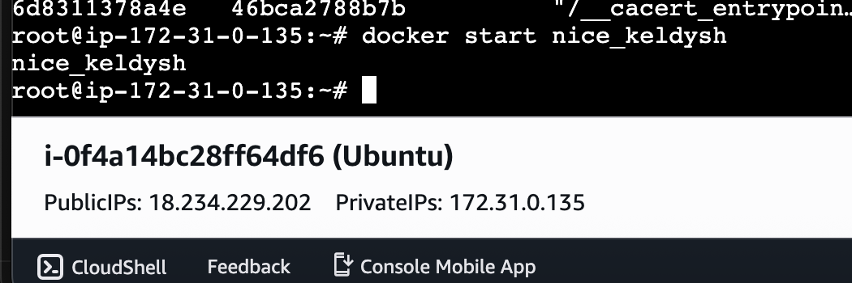
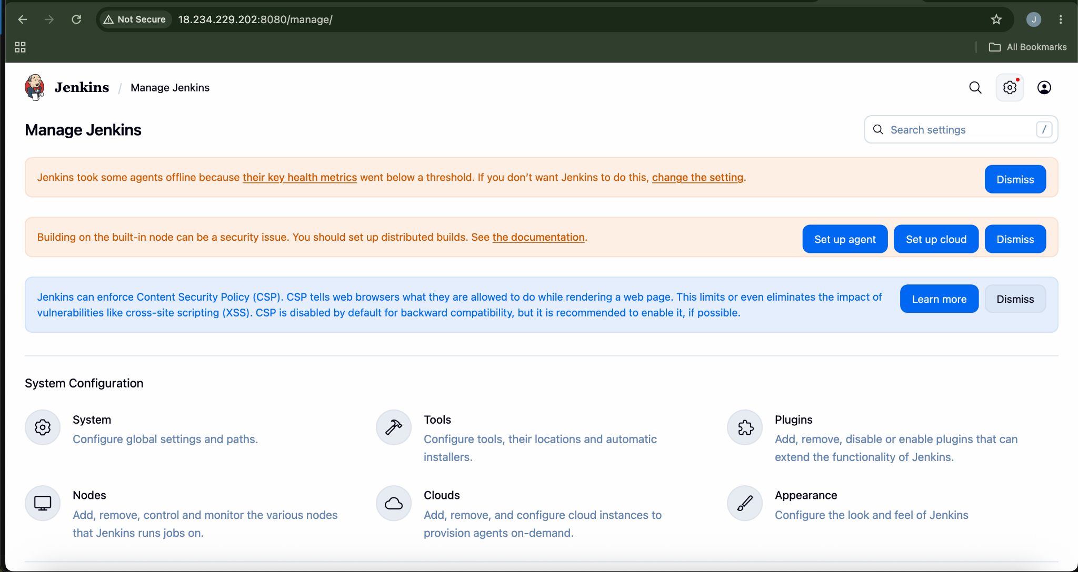
Install Plugin⇒terraform
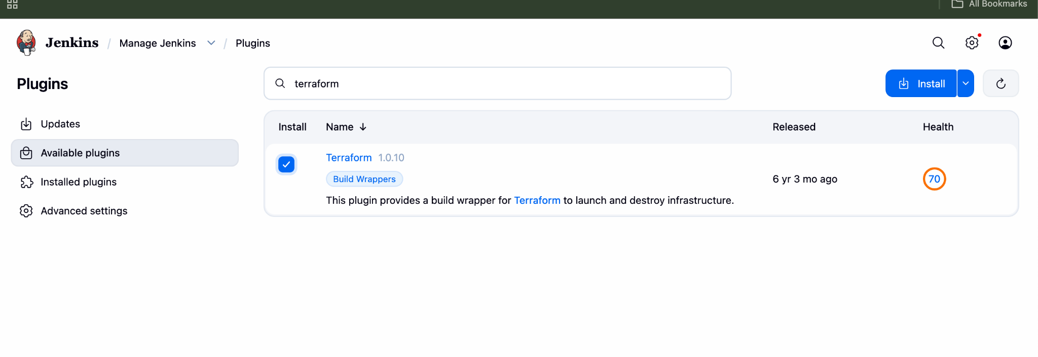
Plugin Installation Successfully
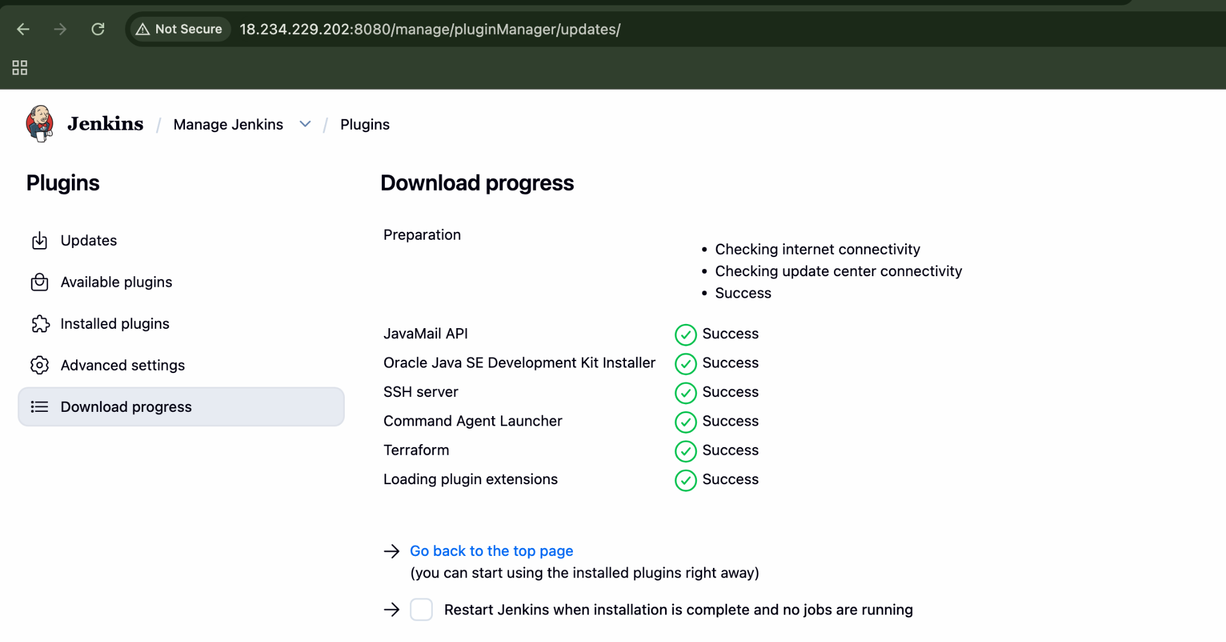
Now lets configure Terraform with Jenkins
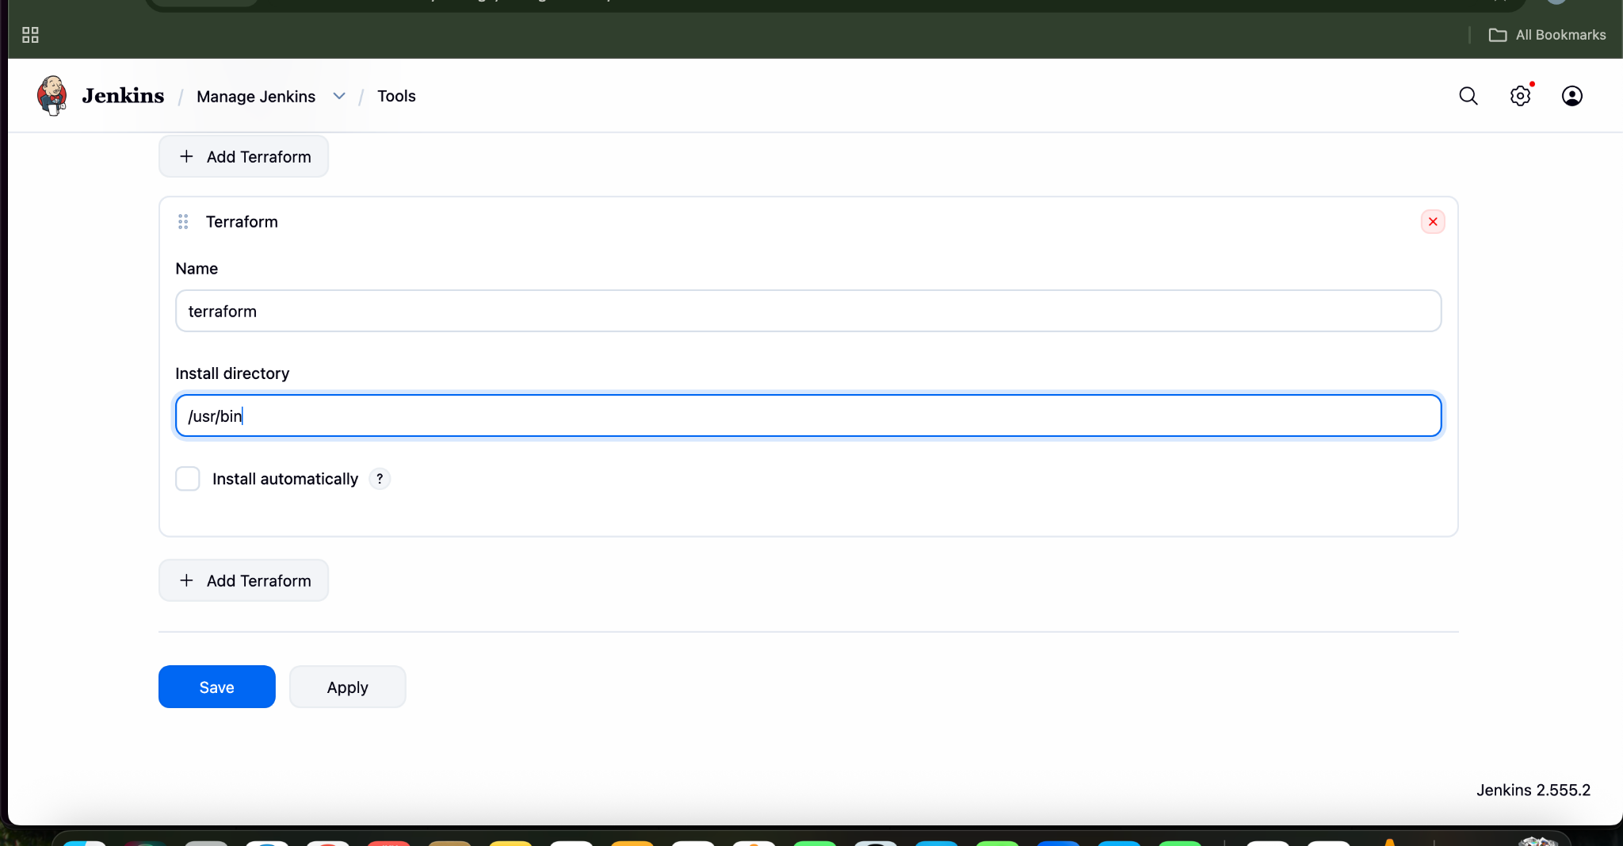

Now terraform has been configured
Now Lets create a main.tf
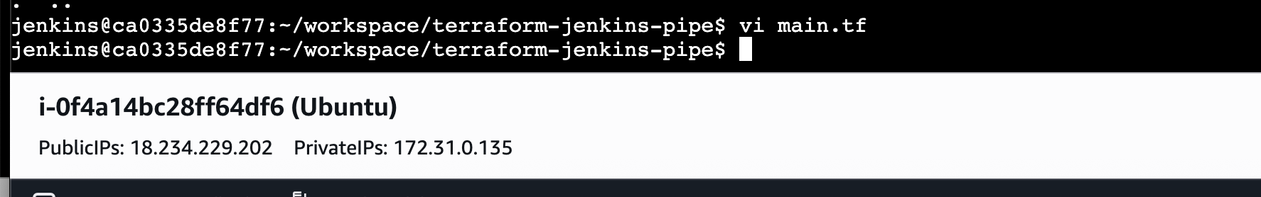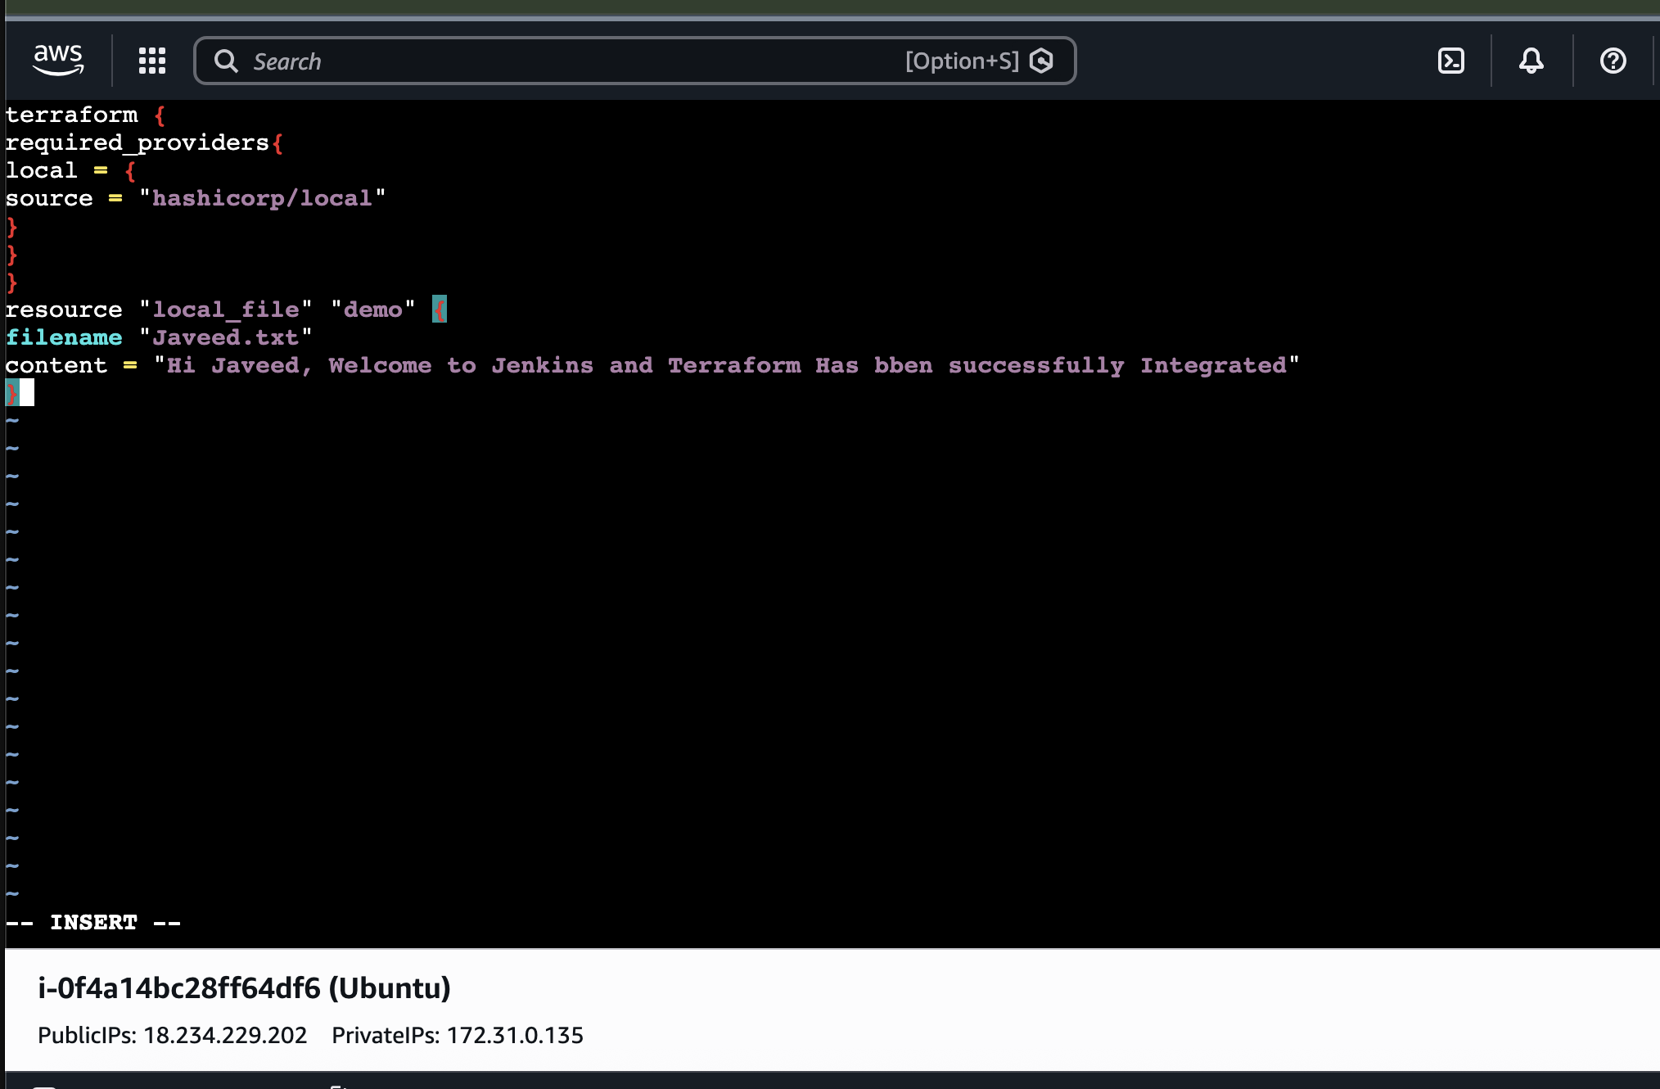
Create a test pipeline job.
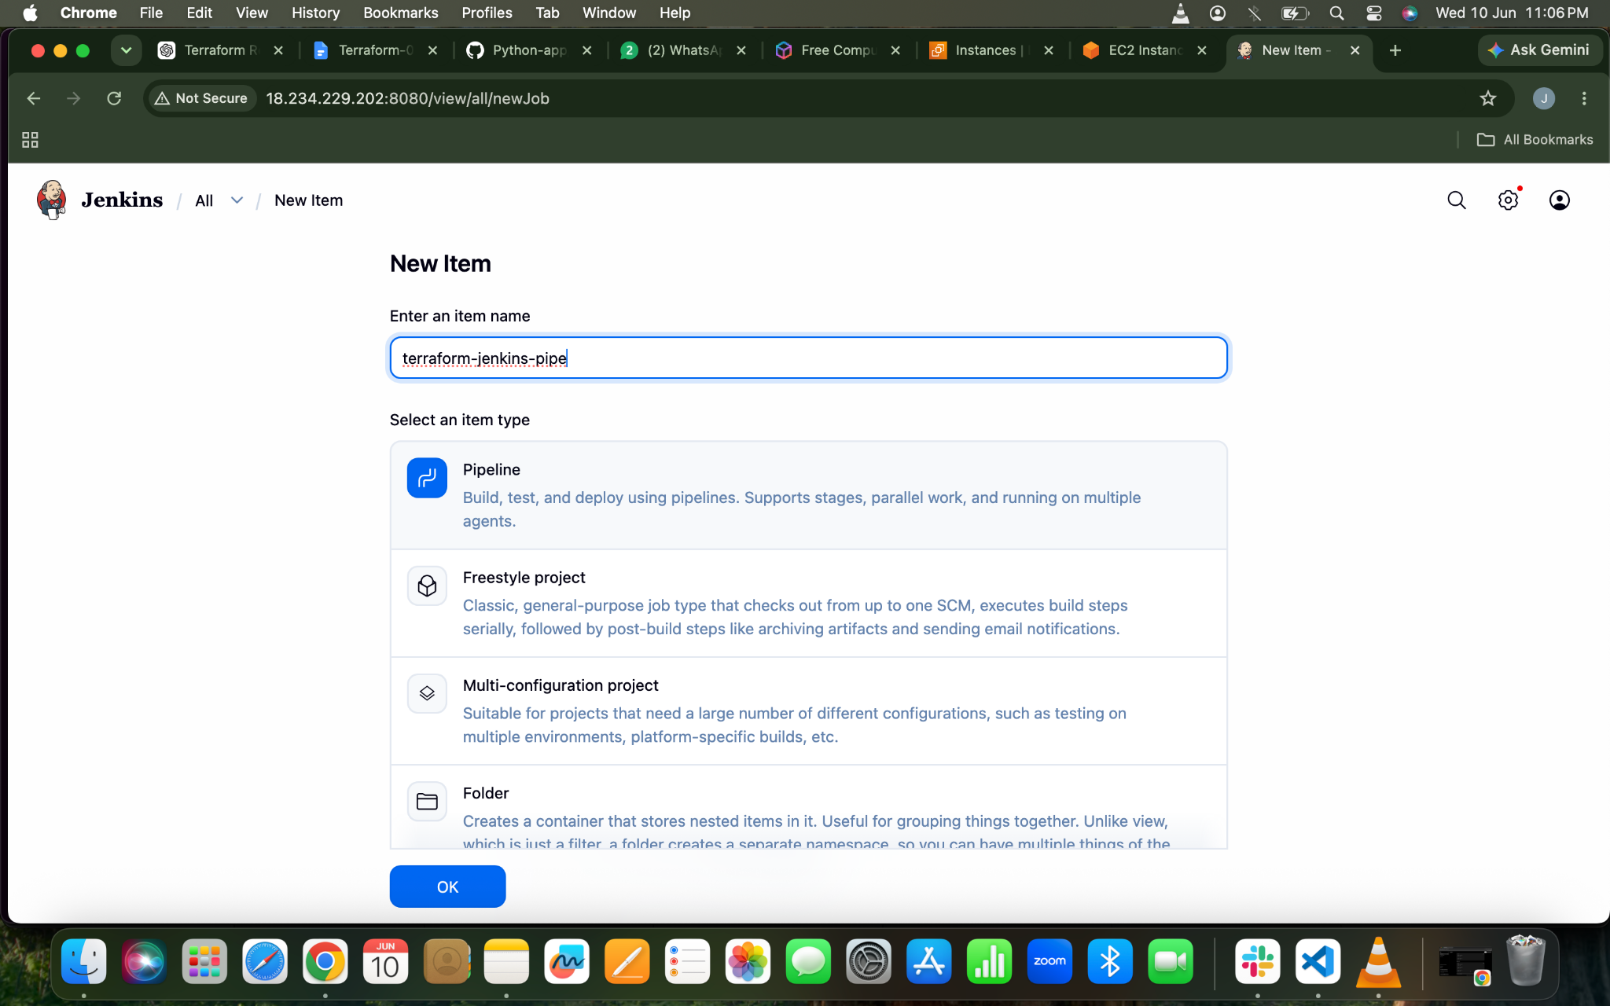
SCRIPT
pipeline {
agent any

tools {
terraform 'terraform'
}

stages {

stage('Check Terraform') {
steps {
sh 'terraform version'
}
}

stage('Terraform Init') {
steps {
sh 'terraform init'
}
}

stage('Terraform Plan') {
steps {
sh 'terraform plan'
}
}

stage('Terraform Apply') {
steps {
sh 'terraform apply -auto-approve'
}
}
}
}

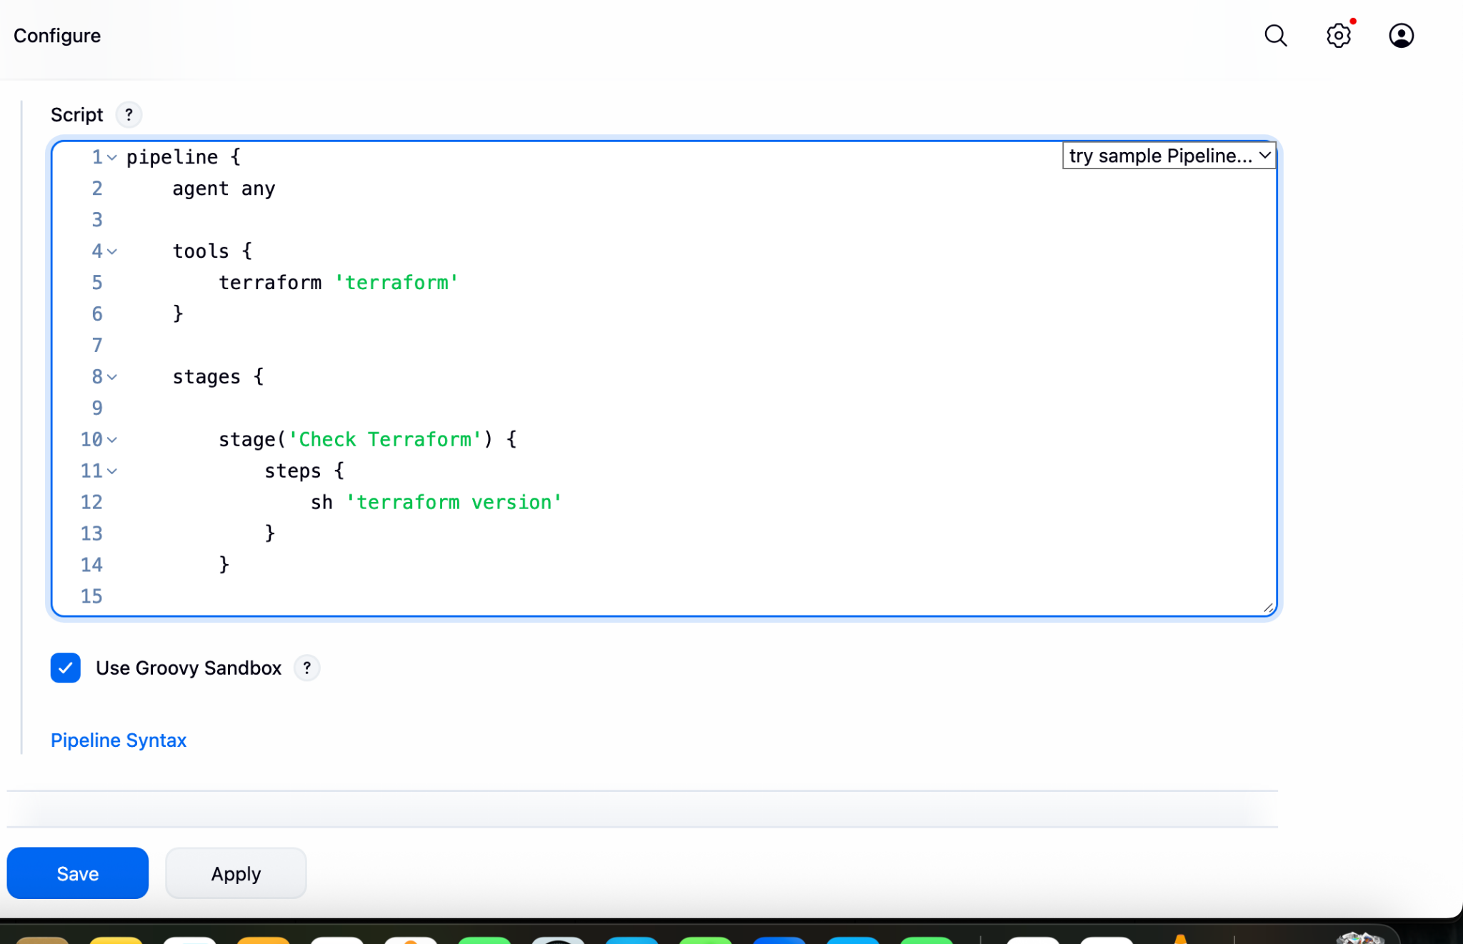

Lets Build The Job

Console Output
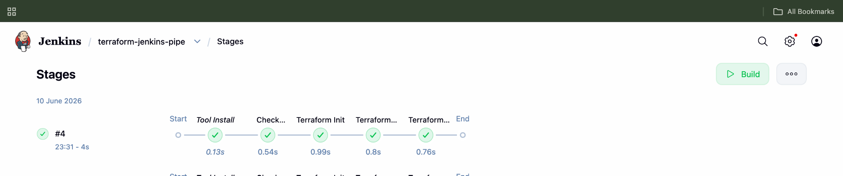
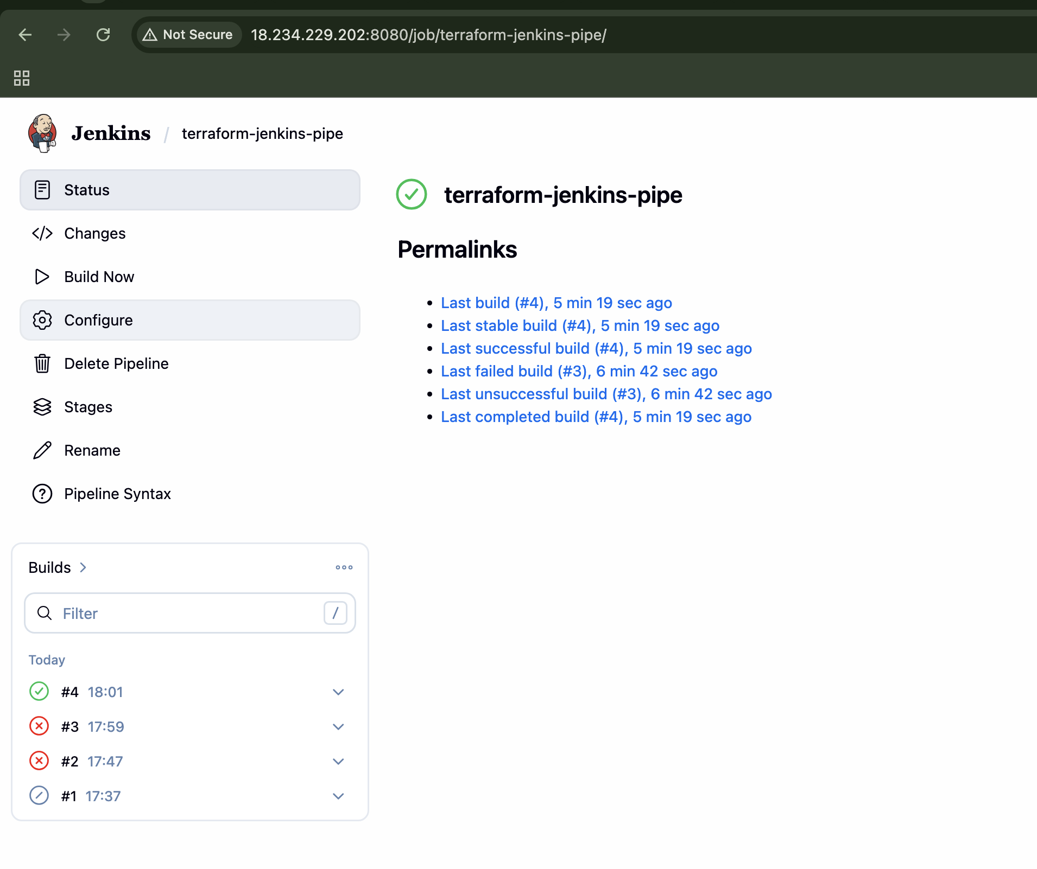
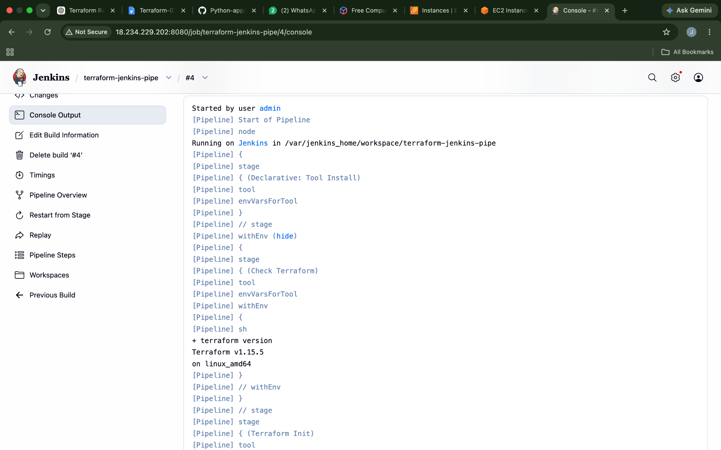

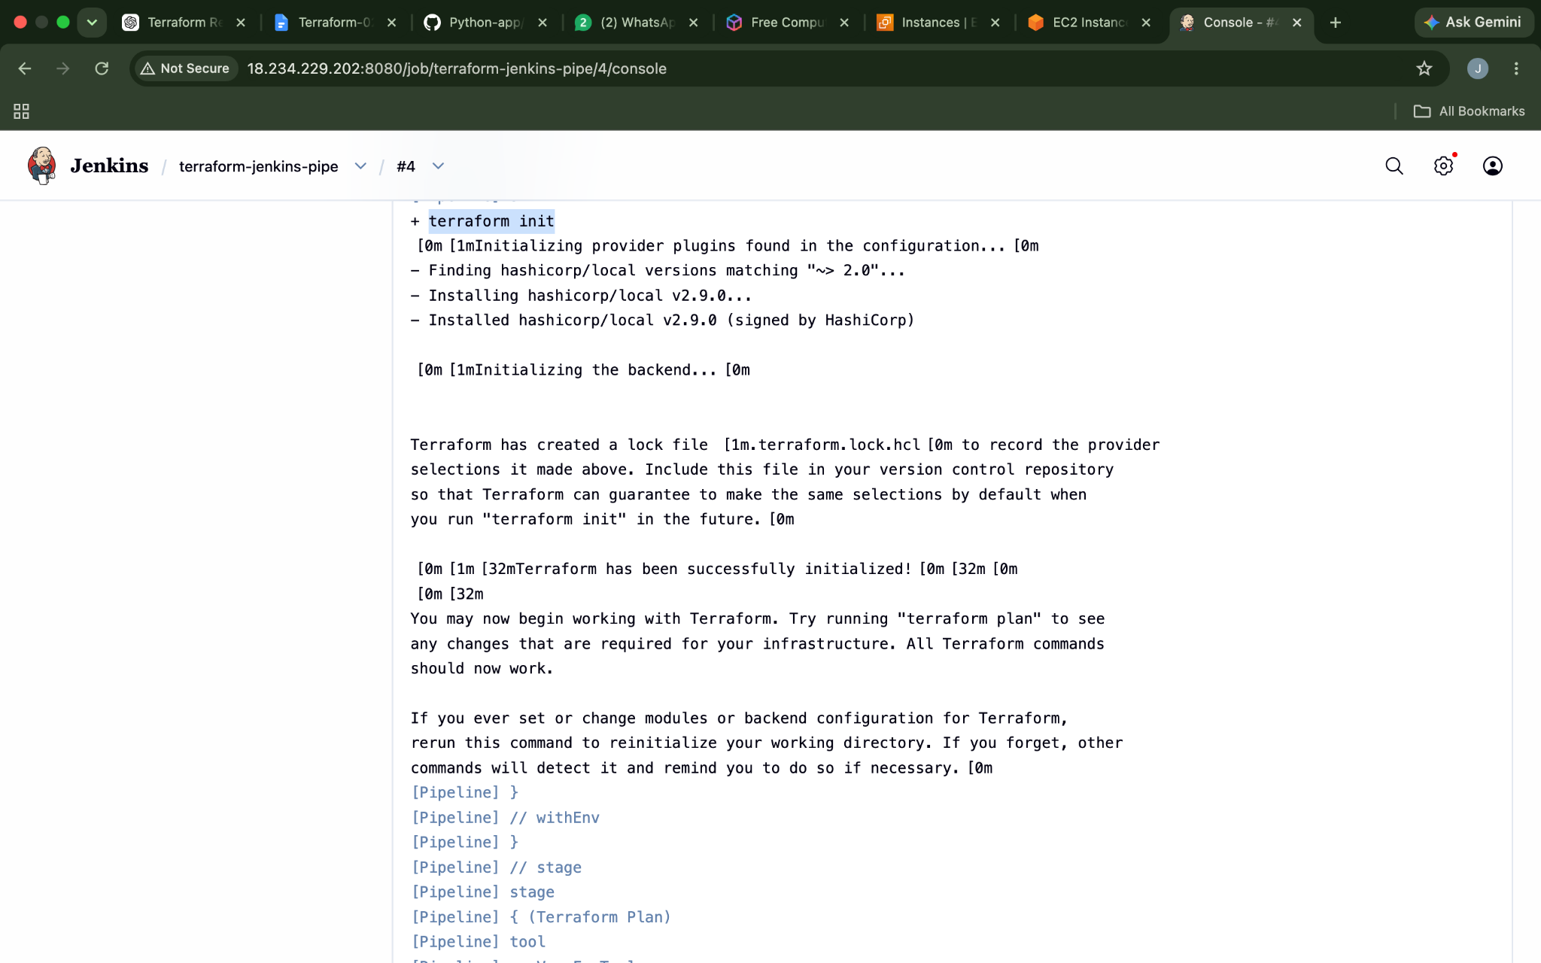
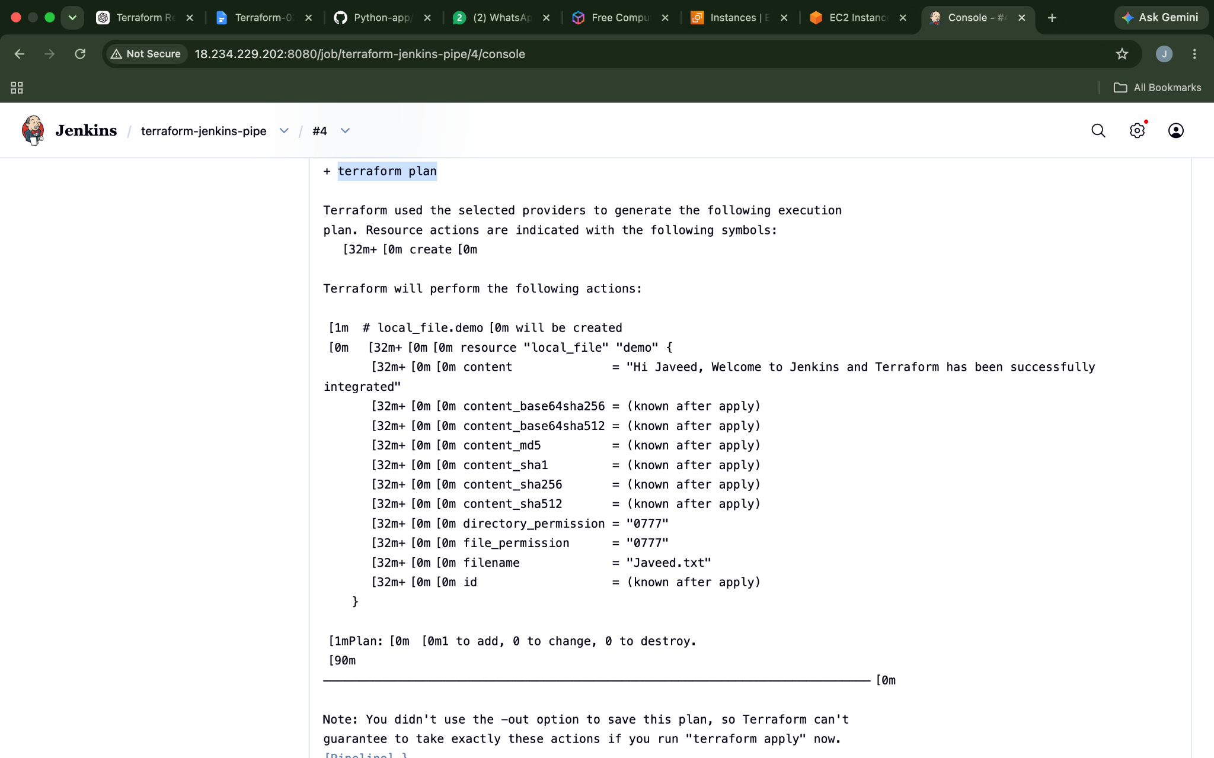
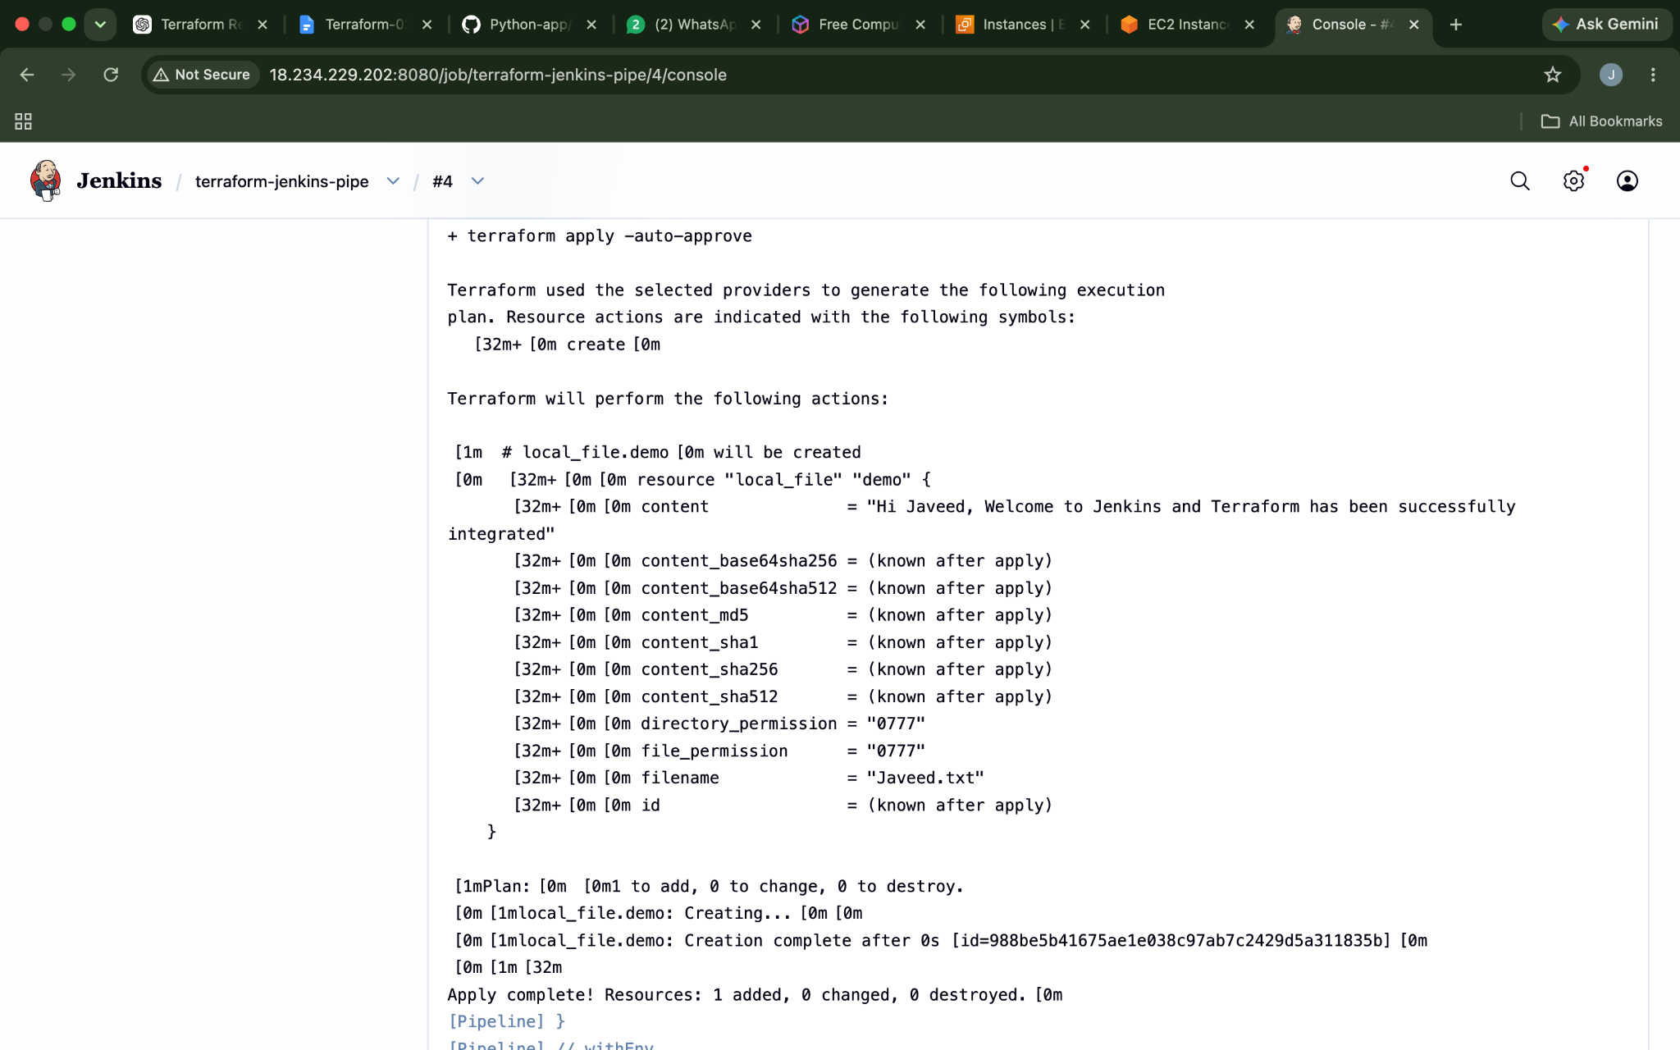
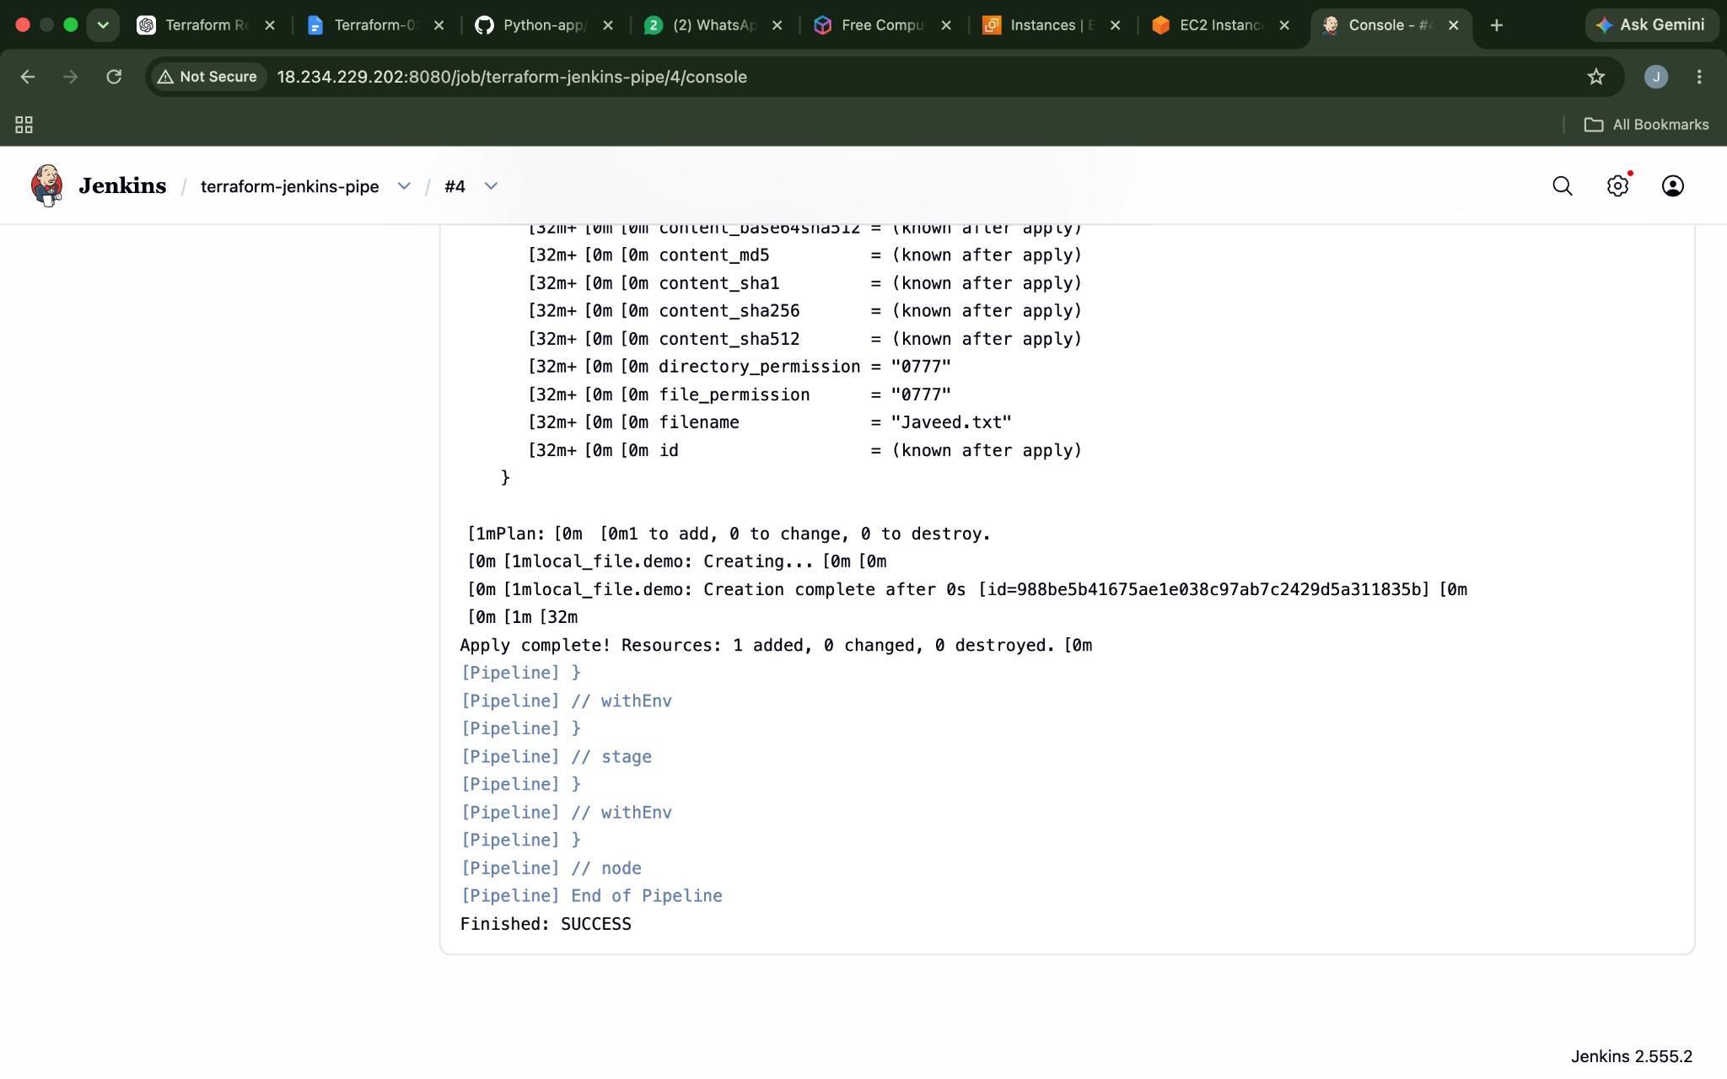
Now the folder has been created
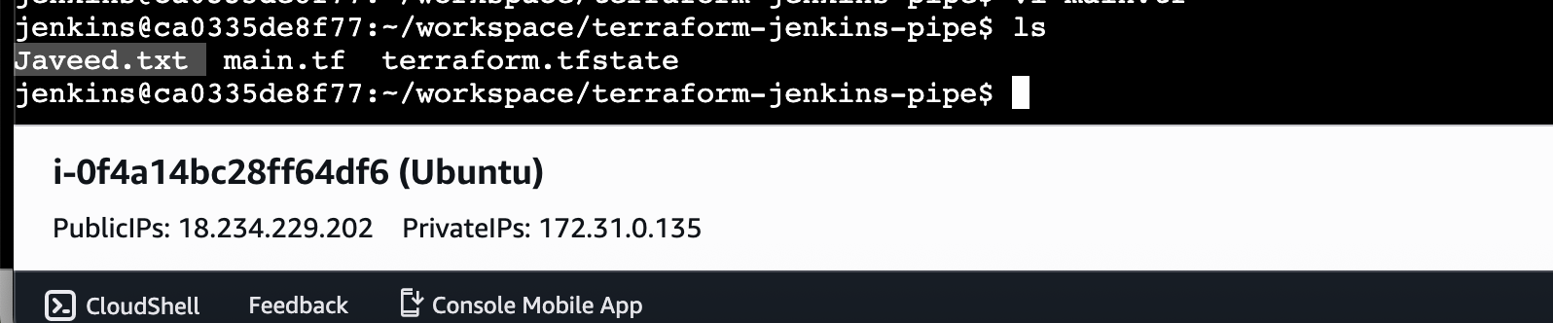

- Create one Jenkins job using Maven Project for the code below with two stages:
  - Stage 1:Git clone
  - Stage 2:Maven CompilationCode:https://github.com/betawins/java-Working-app.git

Lets start Install Maven in Jenkins
Manage Jenkins⇒Tools⇒Maven Installations⇒Name⇒Install Automatically (The reason for doing this is I haven't Installed maven on my jenkins server ) ⇒Version(latest).
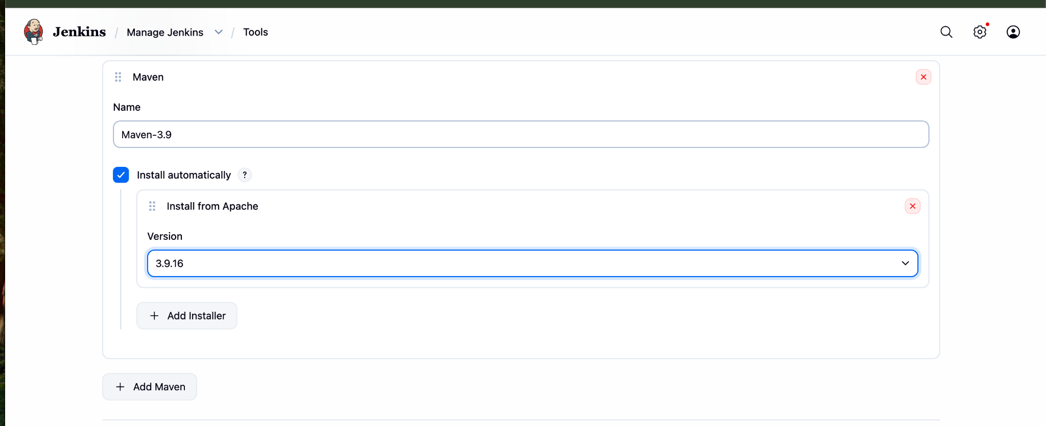
Lets Build a freestyle job
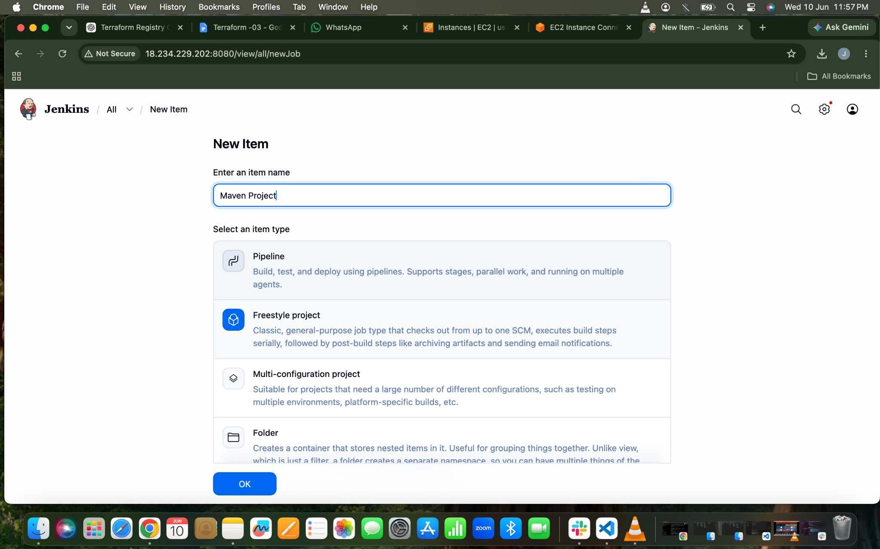
Git Clone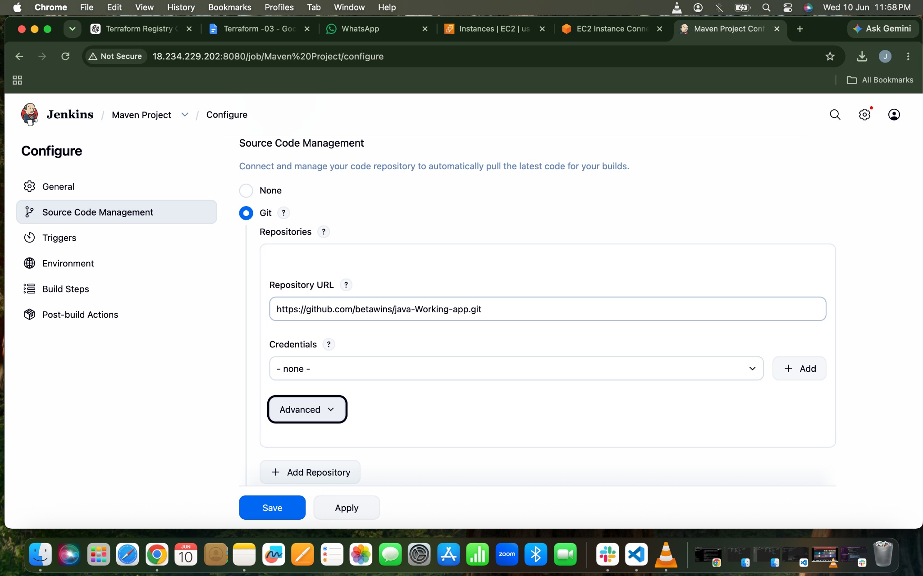

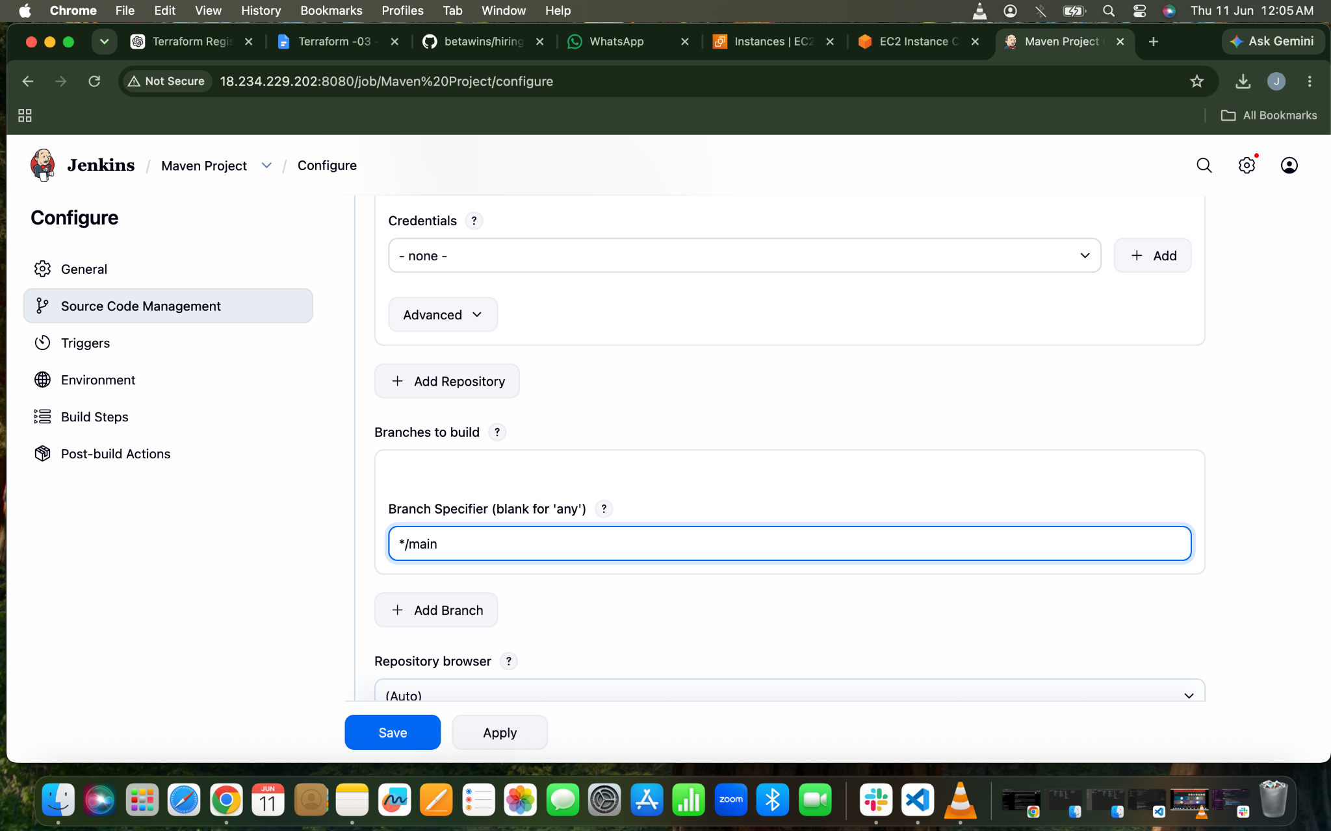
Build Steps
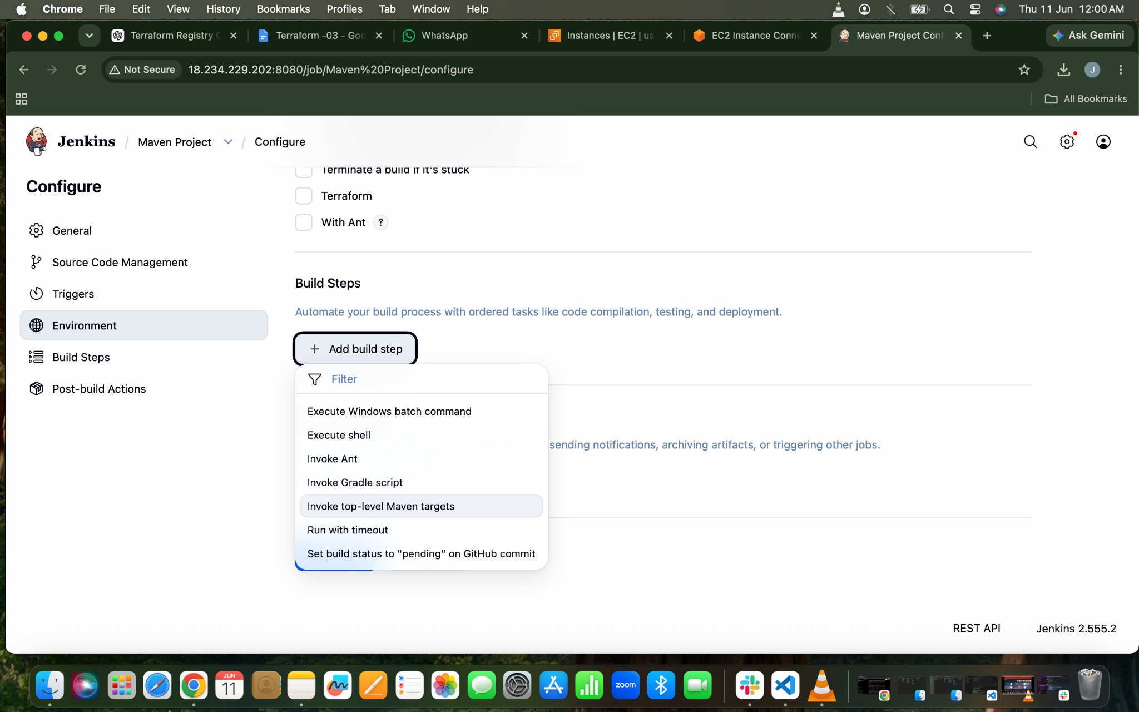
Maven Version ⇒ Which version of maven we have downloaded
Goals ⇒ clean compile ⇒Deletes previous build files and Compiles Java code.

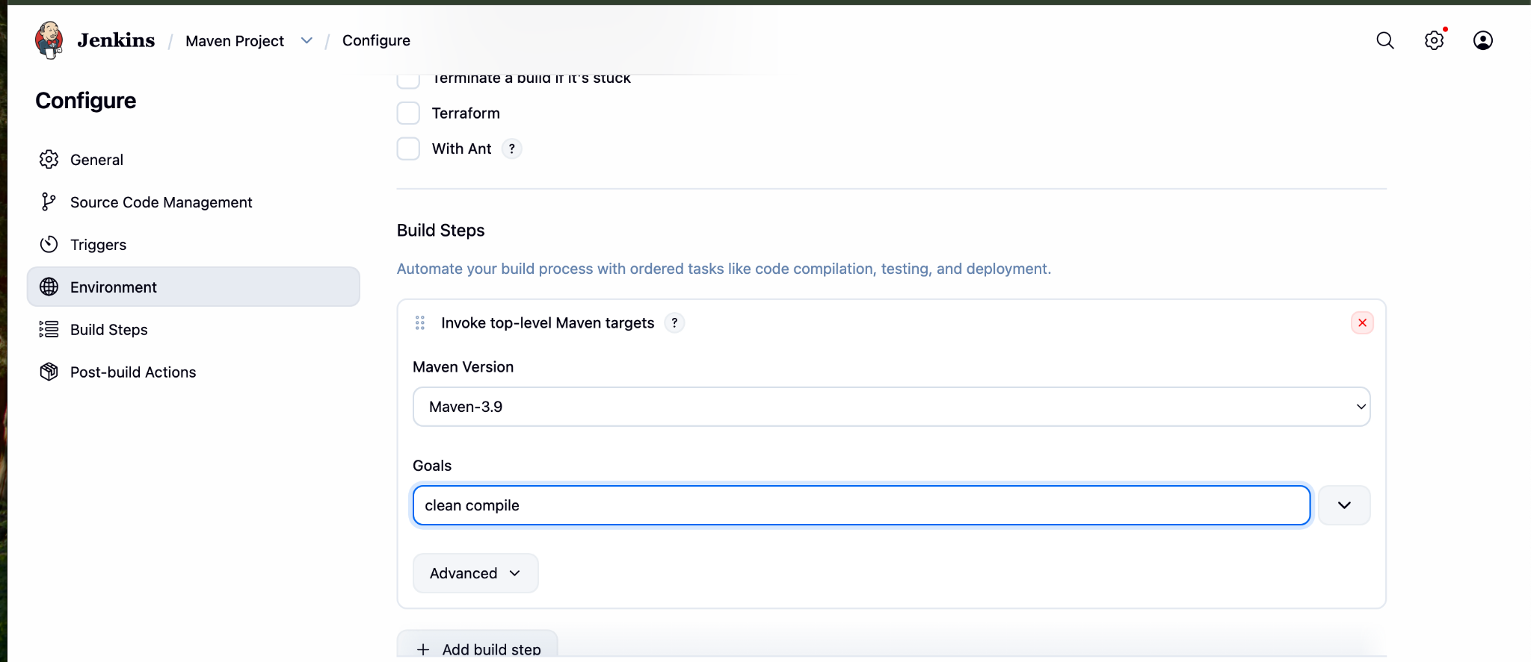
Lets Build The Job
Build Successfull
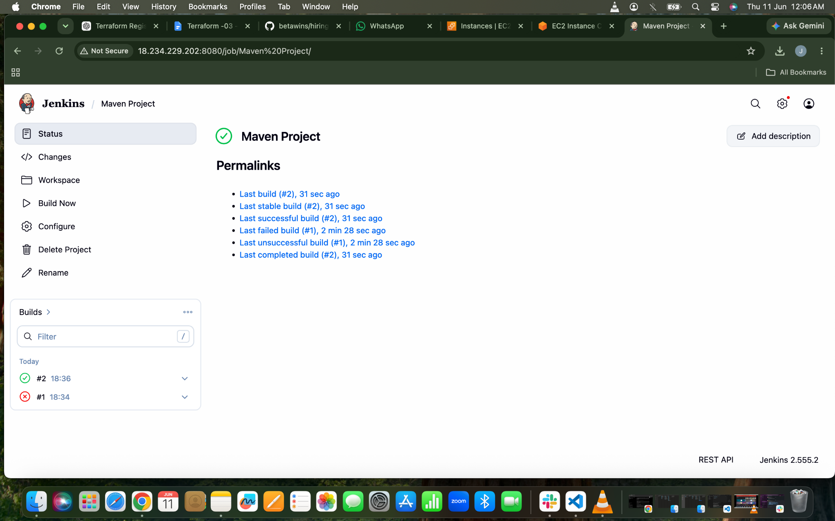
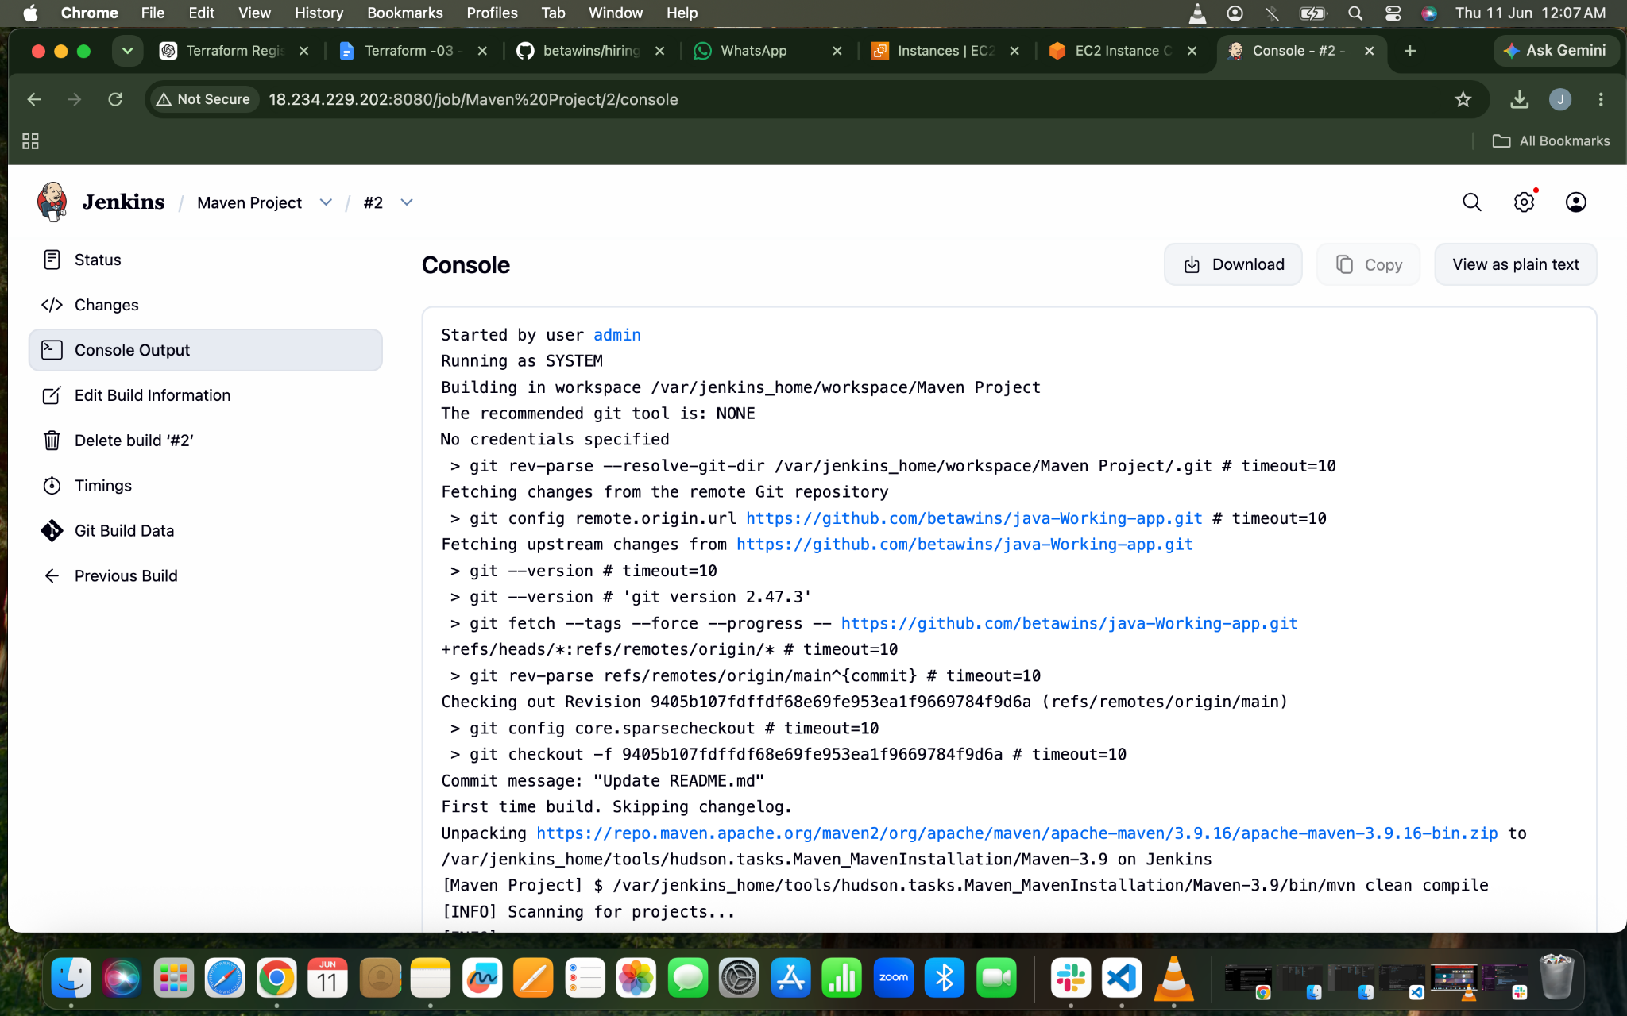
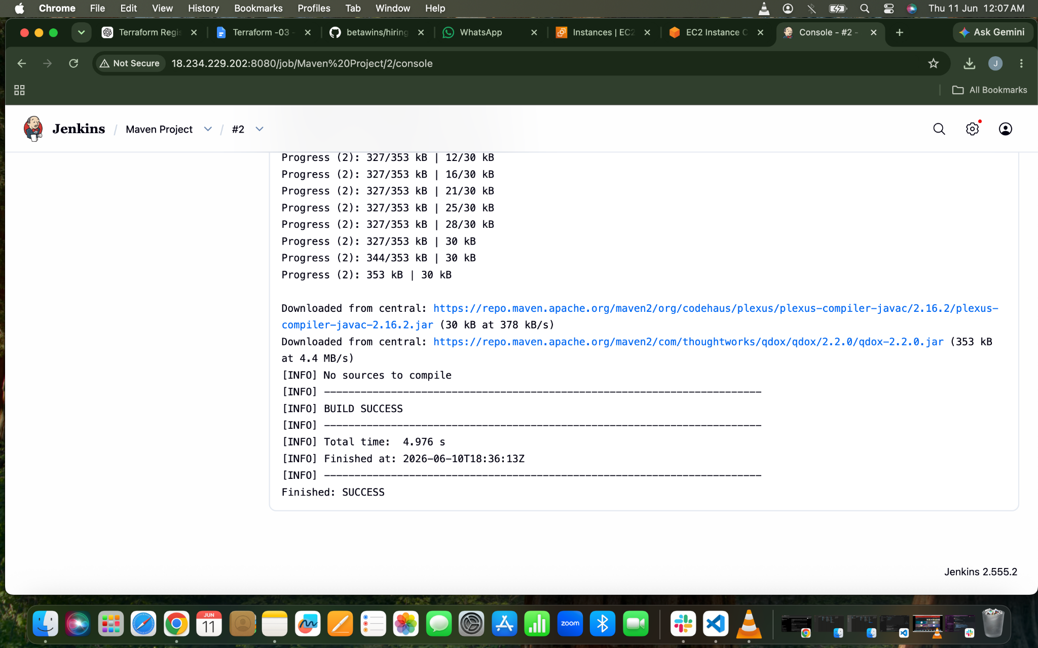
- Use the same code and create a parameterized job in Jenkins with:
  - Stage 1:Git clone
  - Stage 2:Maven CompilationCode:https://github.com/betawins/java-Working-app.git
Lets Create NEw Job First
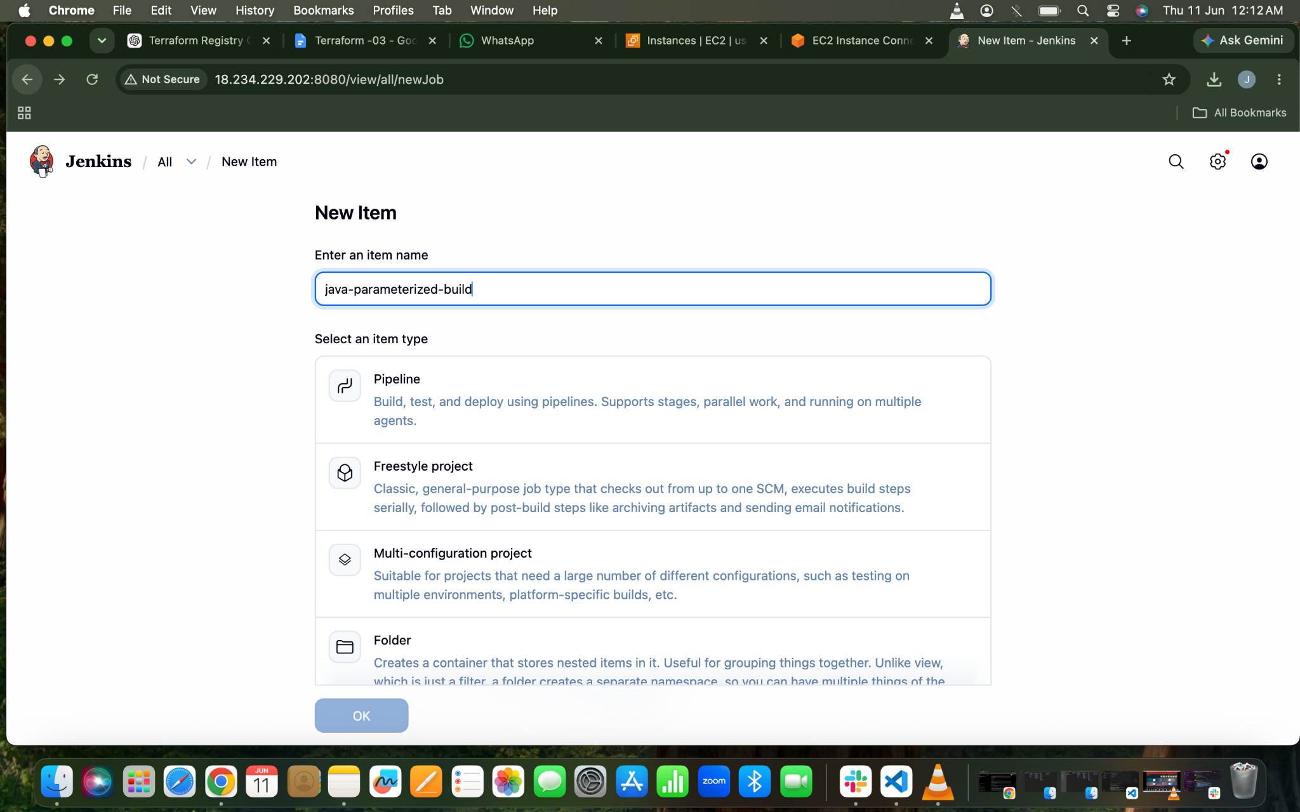
Enable Parameterized Build

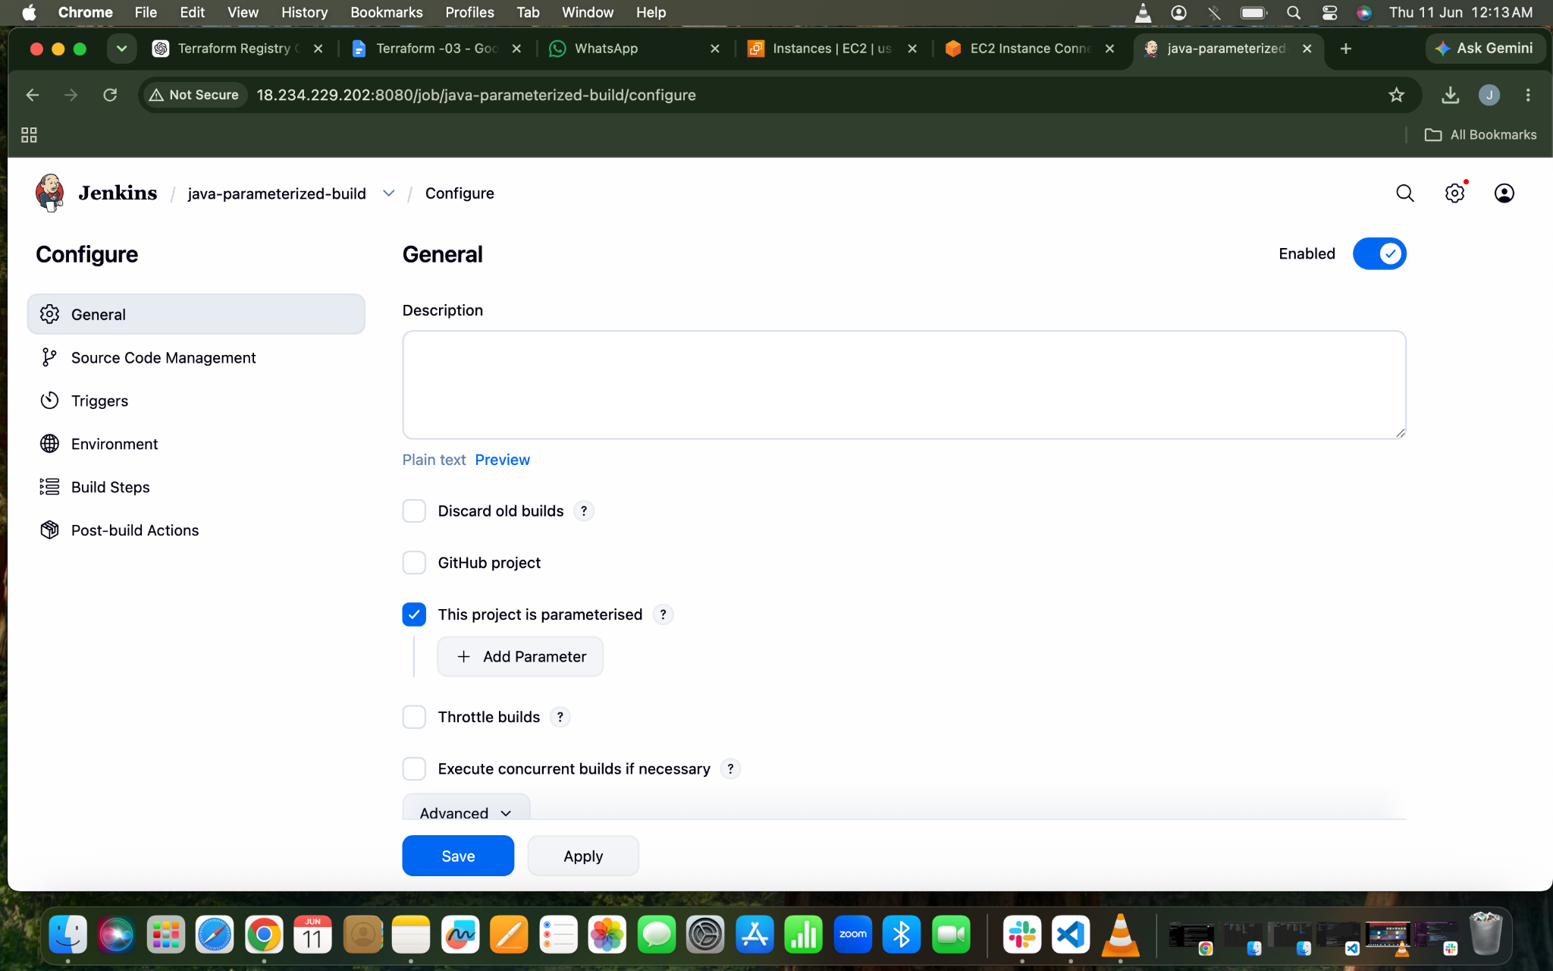
Parameterized Job⇒String Parameter⇒Name (Branch_Name) ⇒Default Value(main) 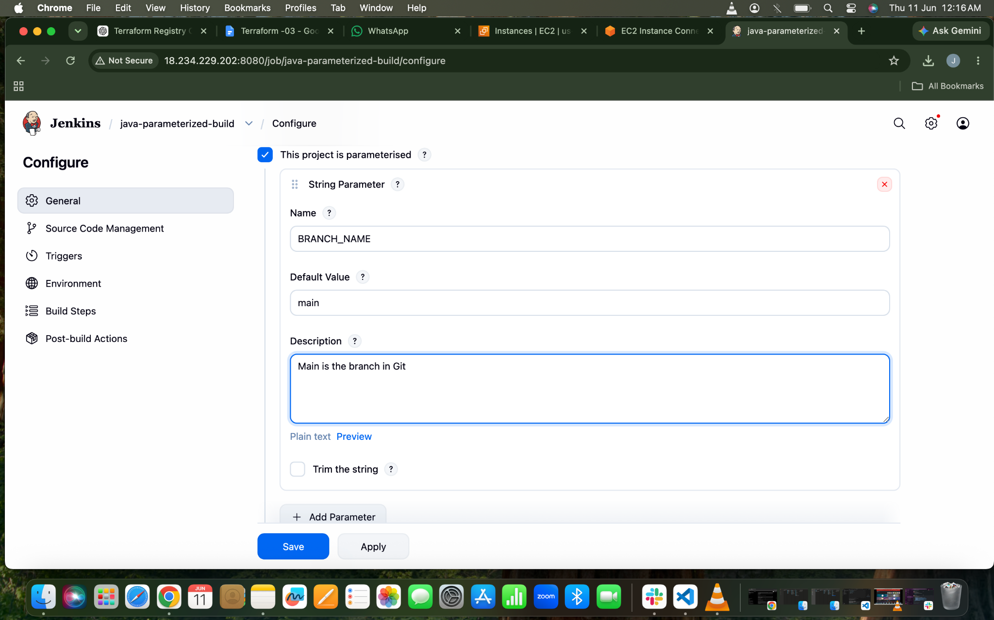
Git Clone
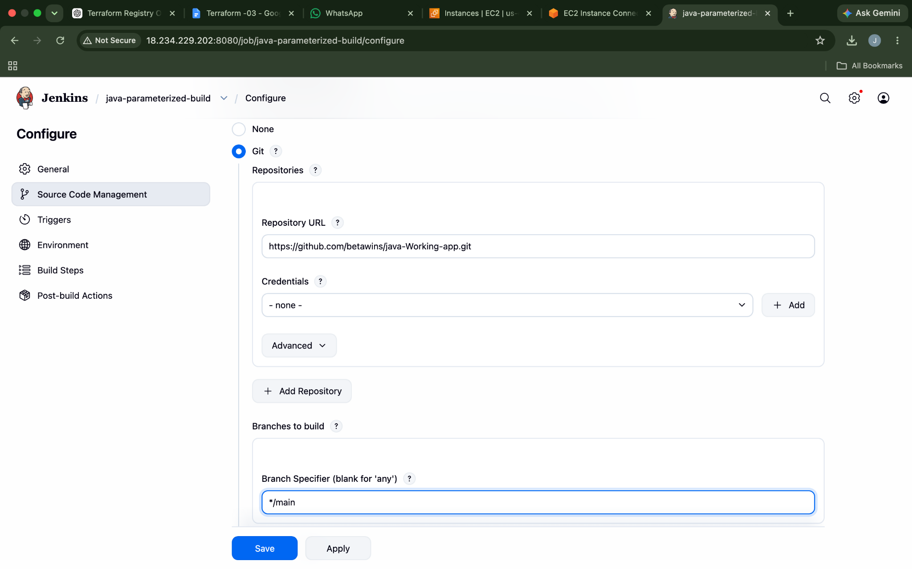
Build Steps⇒Invoke Maven ⇒ Maven Version⇒Goal
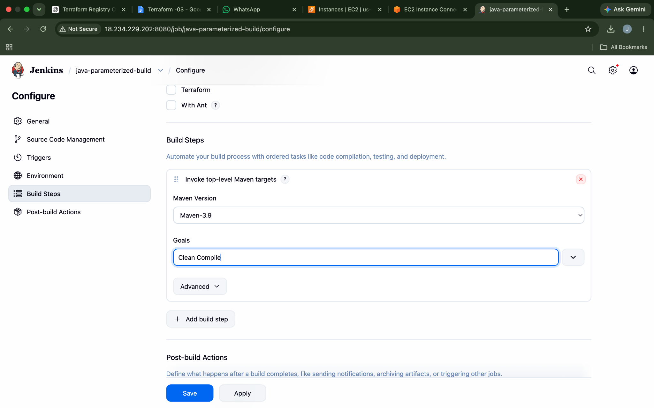
Lets Build The Job
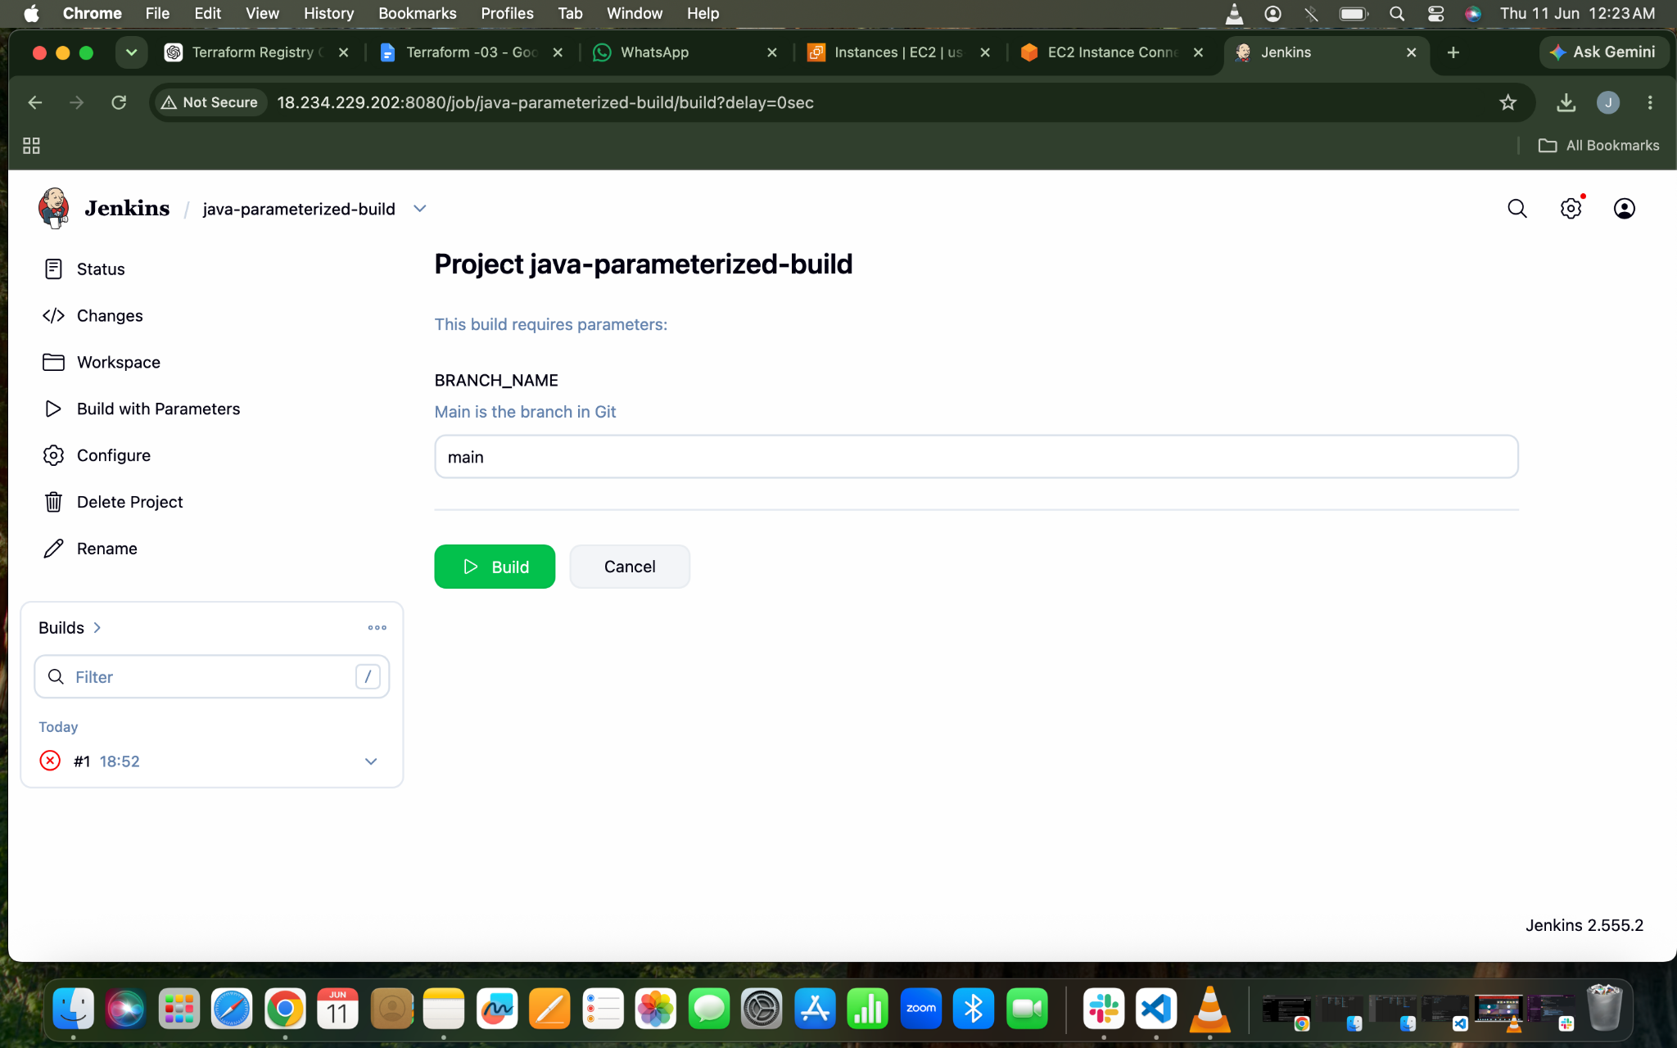
Build Successfull

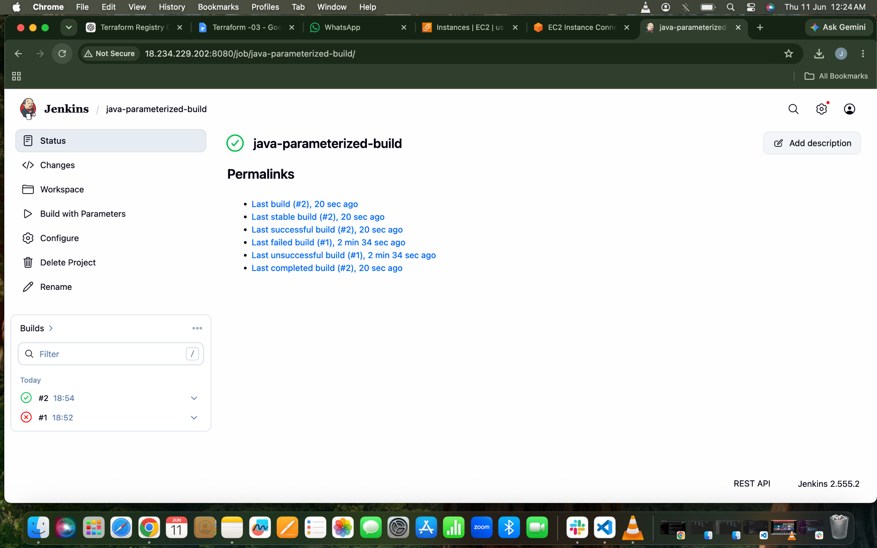
Console Output
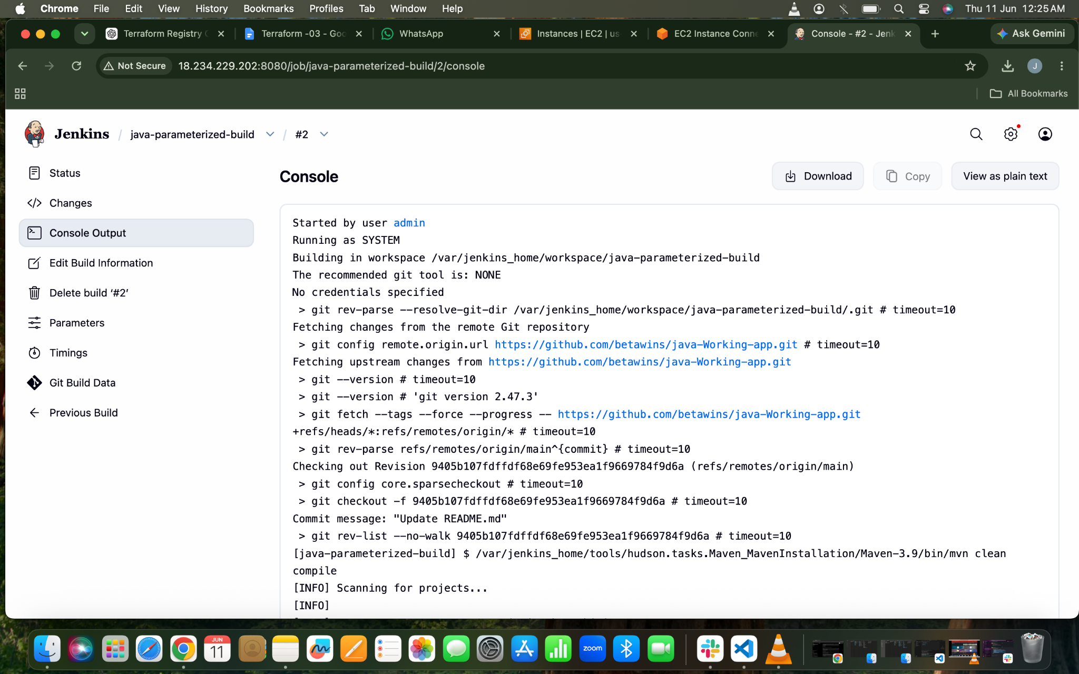
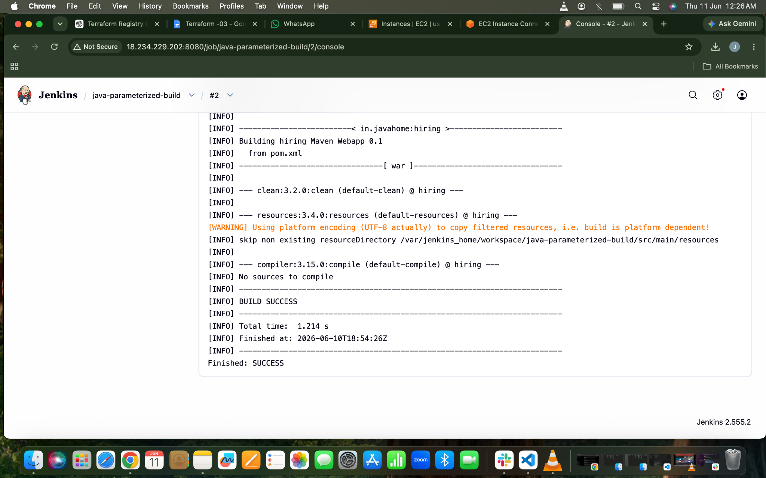

6.What are the global variables in Jenkins?
Global variables in Jenkins are predefined environment variables accessible across jobs and pipelines. They provide build-related information such as build number, workspace path, job name, Git branch, and Jenkins home directory.
Some commonly used global variables include
BUILD_NUMBER, which stores the current build number,
JOB_NAME, which contains the name of the Jenkins job, and
WORKSPACE, which defines the location where Jenkins clones the source code and executes builds.
Variables like GIT_COMMIT and GIT_BRANCH help identify the exact Git commit and branch used during the build process.
These global variables are useful in automation, scripting, and CI/CD pipelines to make Jenkins jobs more dynamic and reusable.

